**BUSINESS OBJECTS ADVANCED**

1. **APPLYING COMBINED QUERY USING UNION**

Step 1: Logon to business object using link

<http://10.74.163.233:8080/BOE/BI>

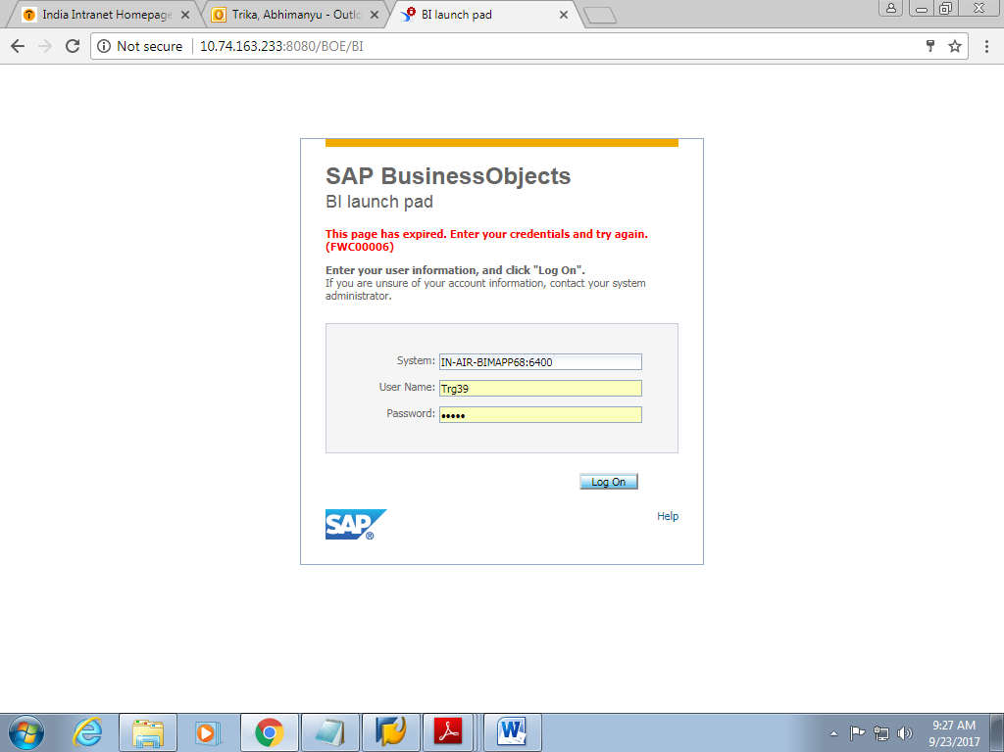

**Step 2:** Now Home page will appear as follows:

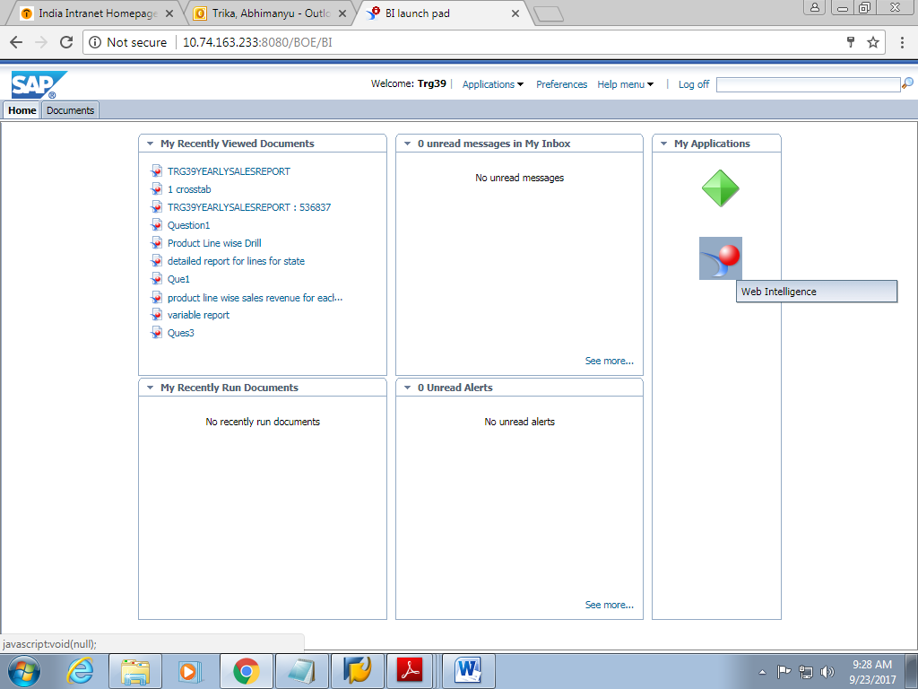

Step 3: on clicking on web intelligence button, A window will appear

Click on new button to create a report

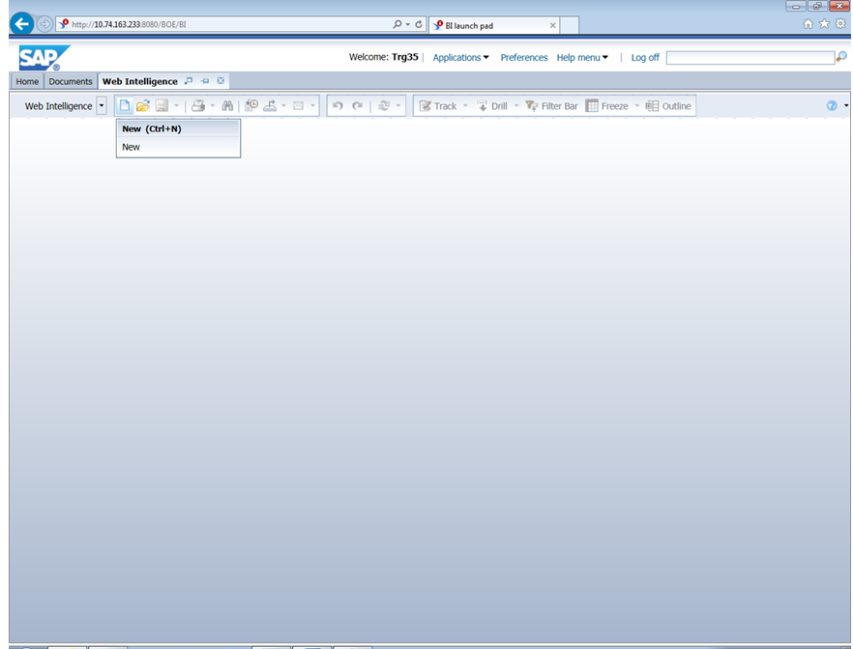

Step 4: click on universe to create report

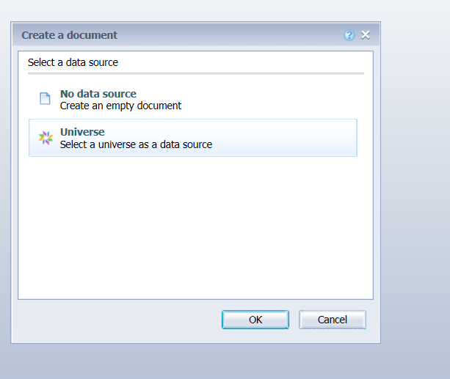

Step 5: now select efashion universe for creation

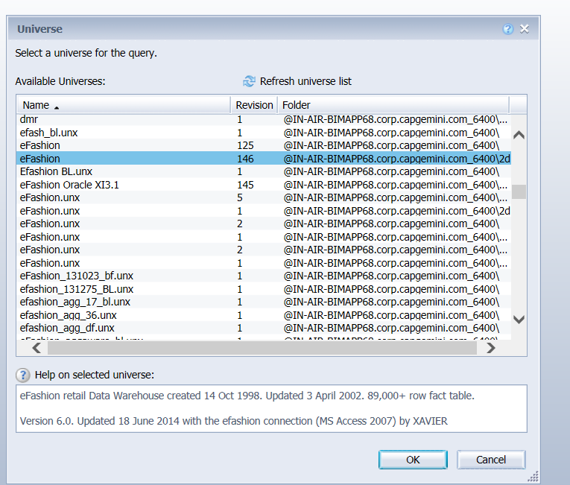

Step 6: on clicking on ok, a query panel will open as

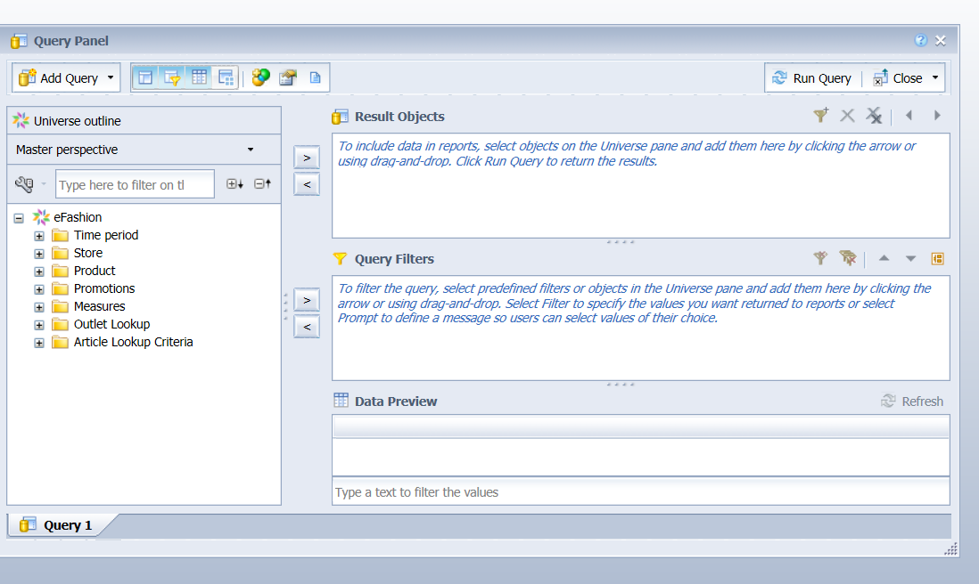

Step 7: now drag and drop dimensions to the result objects

Drag year, line and sales revenue

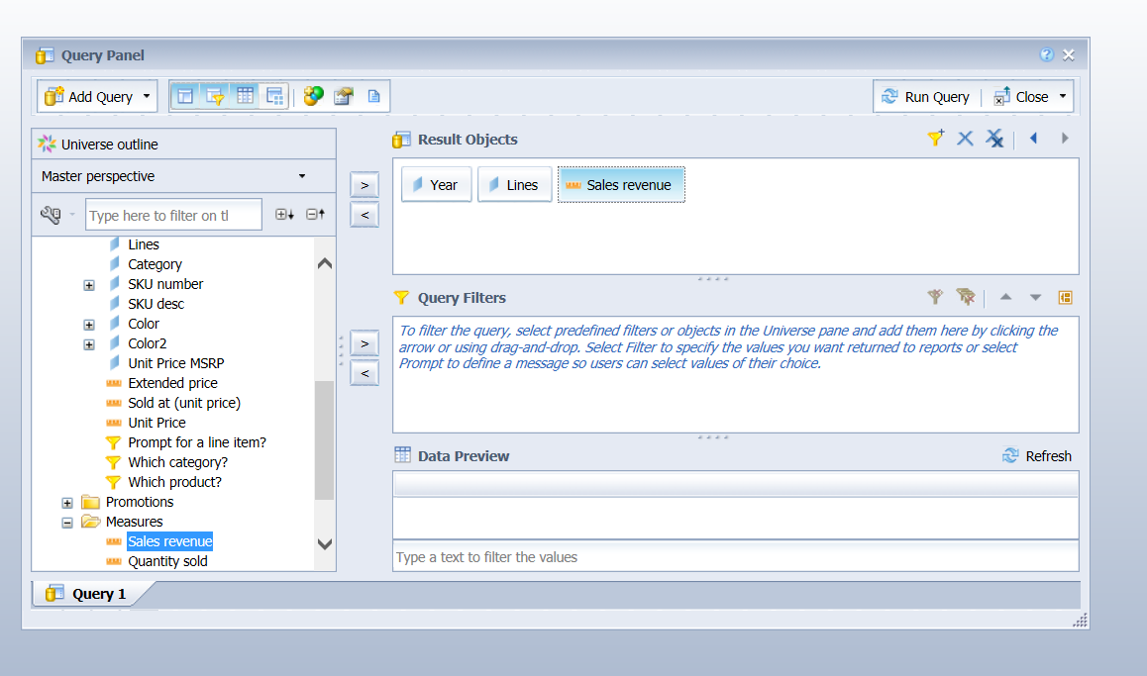

Step 8: now click on run query , the report will look like as

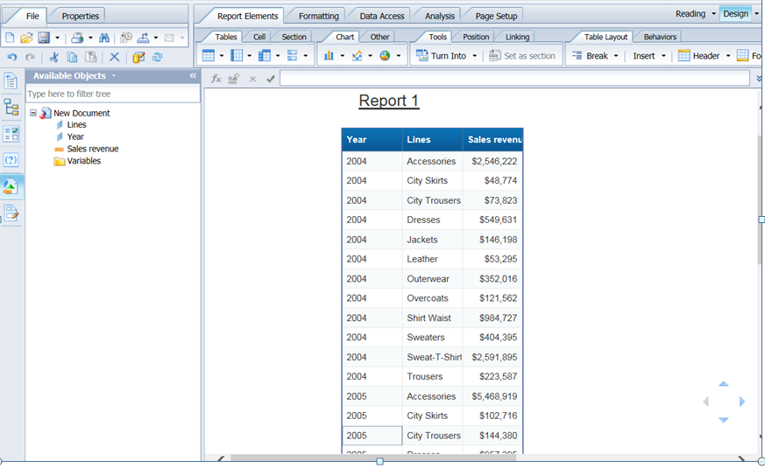

Step 9: click on data access tab

Then click on edit in the toolbar and then to ‘add combined query’

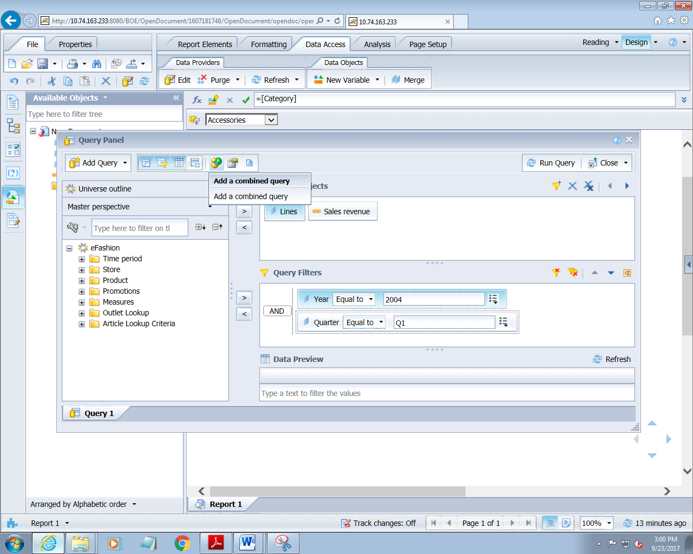

Step 10: now click on combined query 1 and create the filter as

Year equals to 2004

Sales revenue>10000

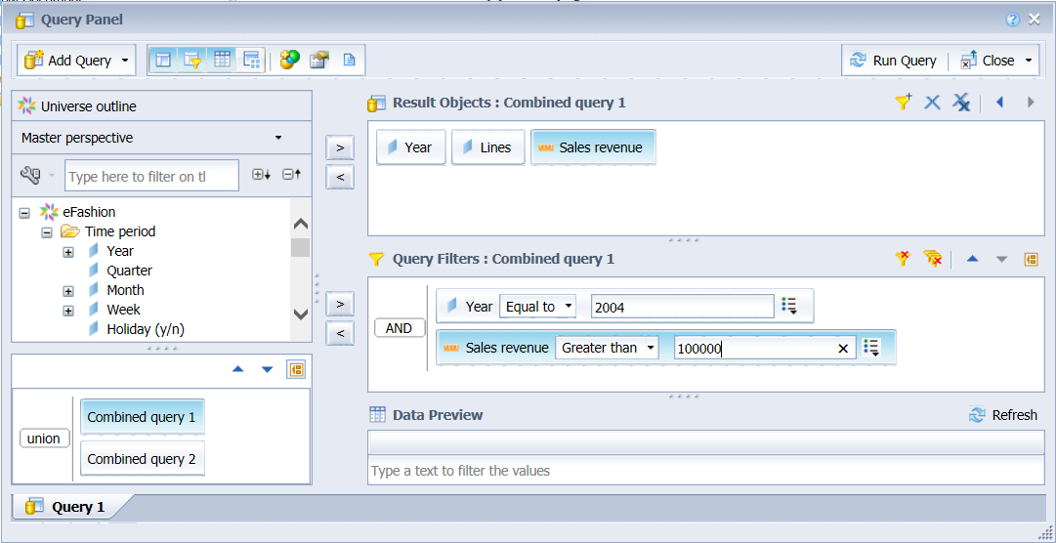

Step 11: click on combined query 2 and create filter as

Year equal to 2005

Sales revenue>110000

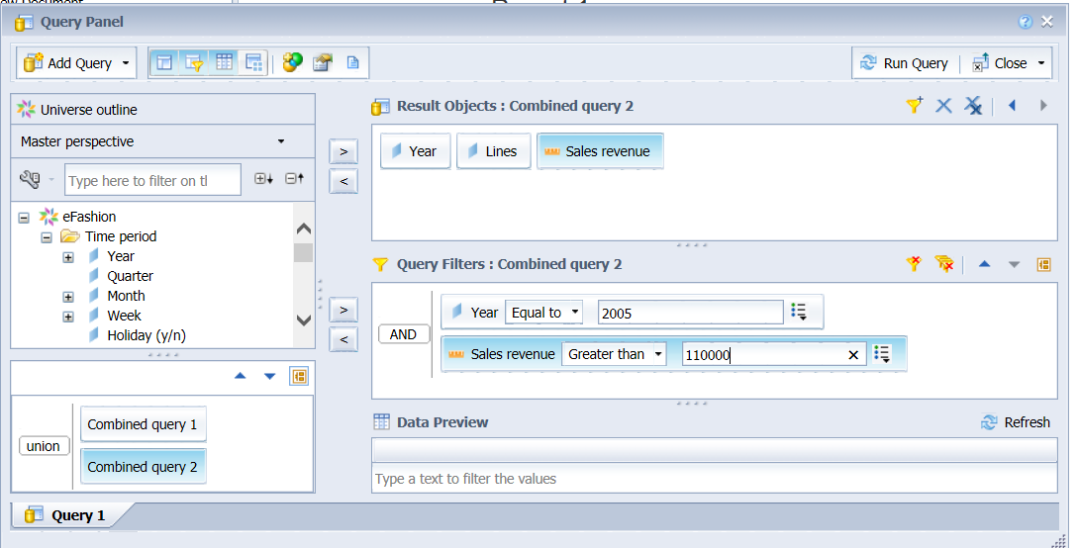

Step 12: click run to see the report

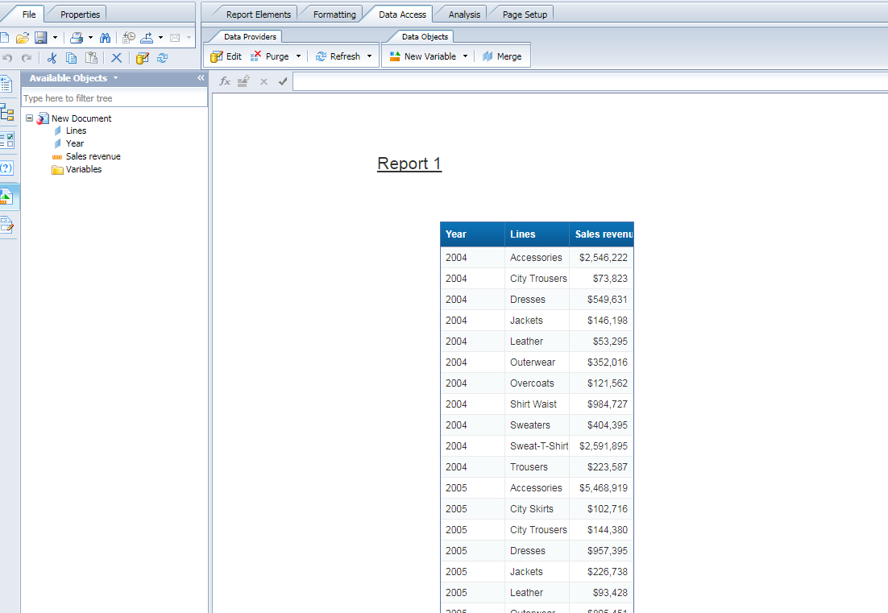

* 1. **USING STRING HANDLING FUNCTION**

1. Create a report using following dimensions

Line, category, SKU desc, sales revenue

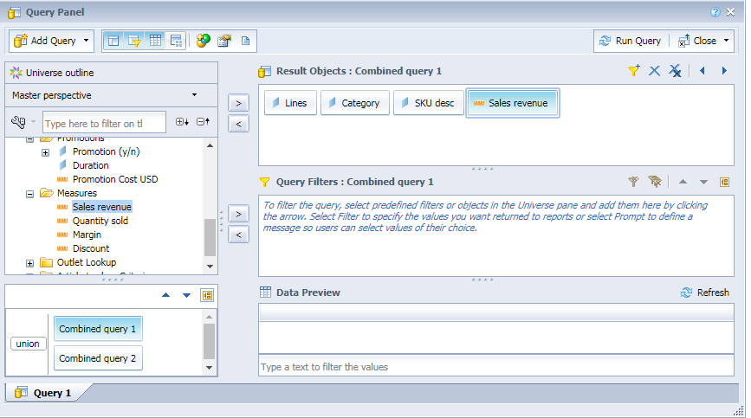

1. Add two filter

State and year, prompt these filters

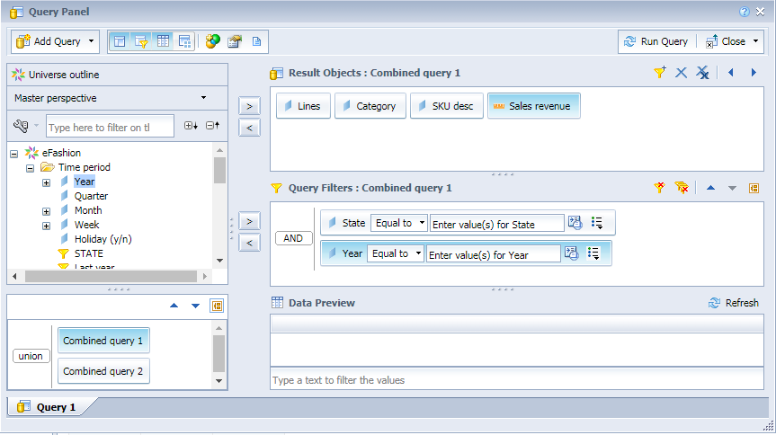

1. On clicking on run query , a prompt window will open asking for entering the value

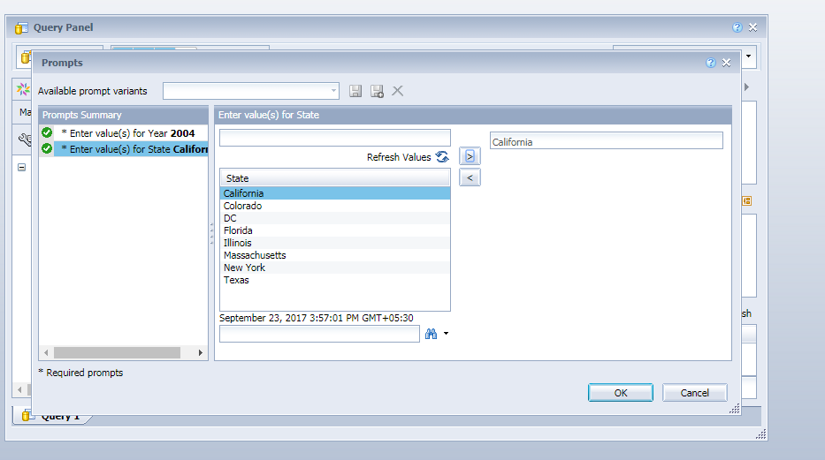

1. On clicking on ok, the following report will appear as

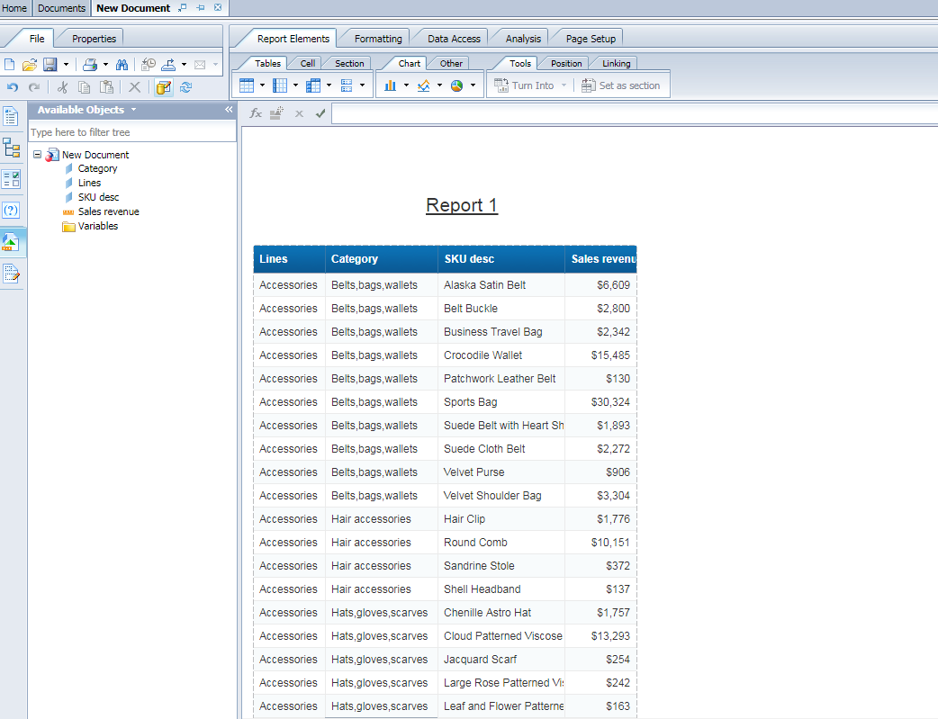

1. Now click on new variable tab from the toolbar

Give a variable name as “product full name”

Set qualification to dimension

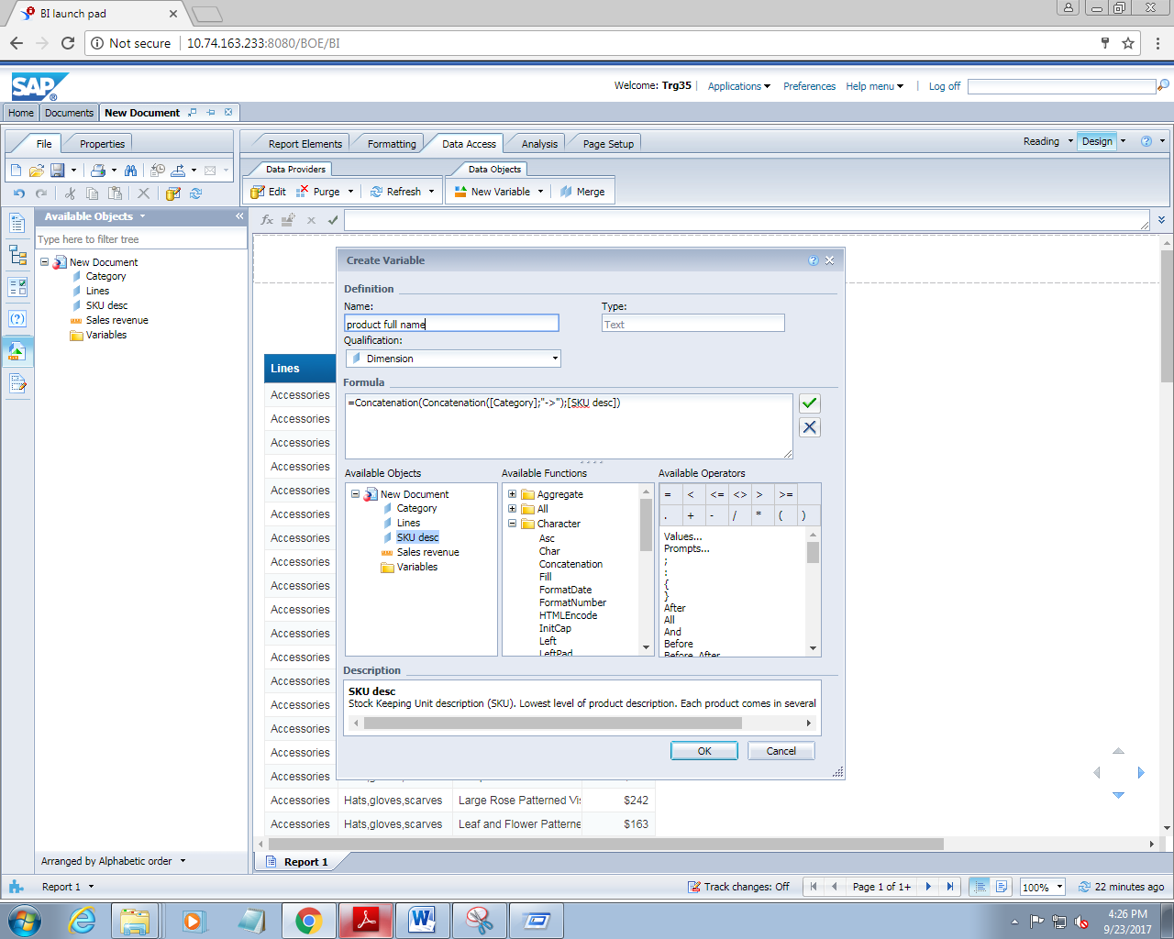

1. Remove category and SKU desc column from the report now and insert a column after line

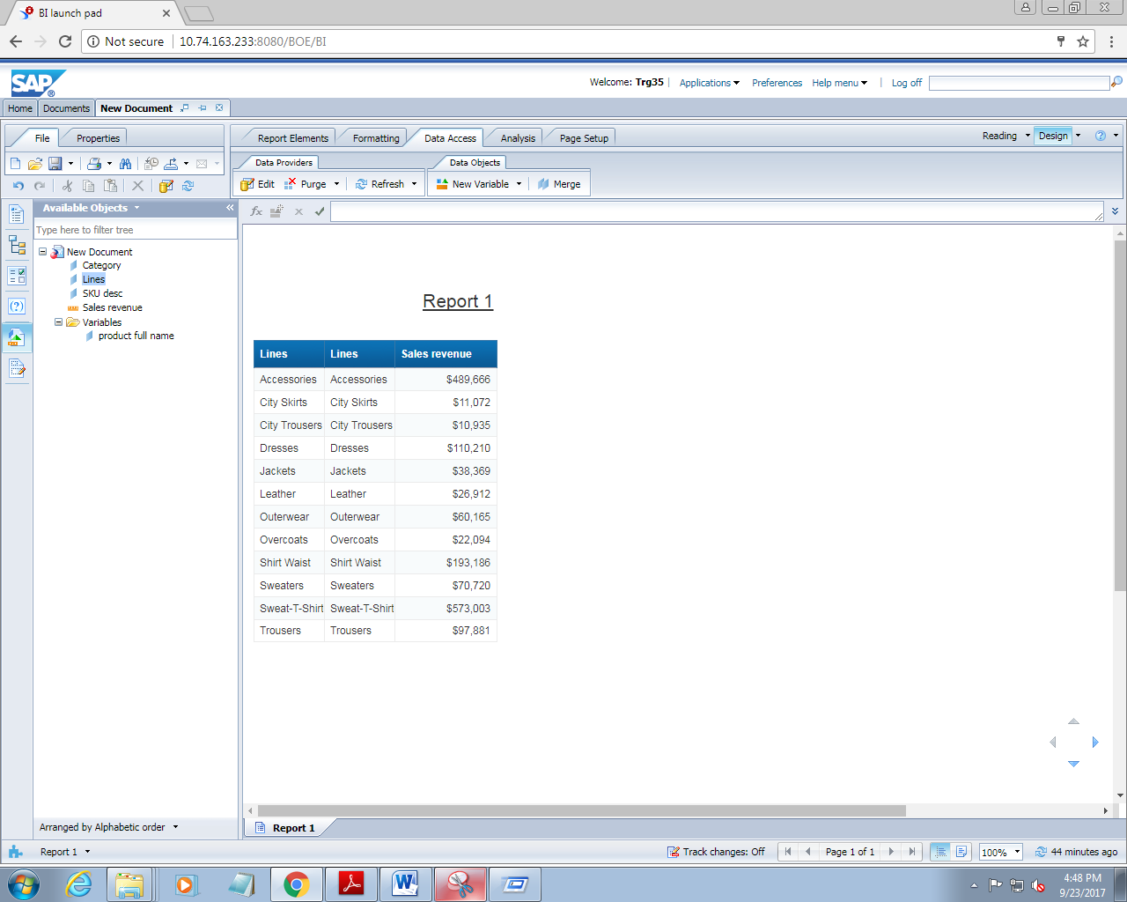

1. Now drag the variable name which you created to the newly created blank column

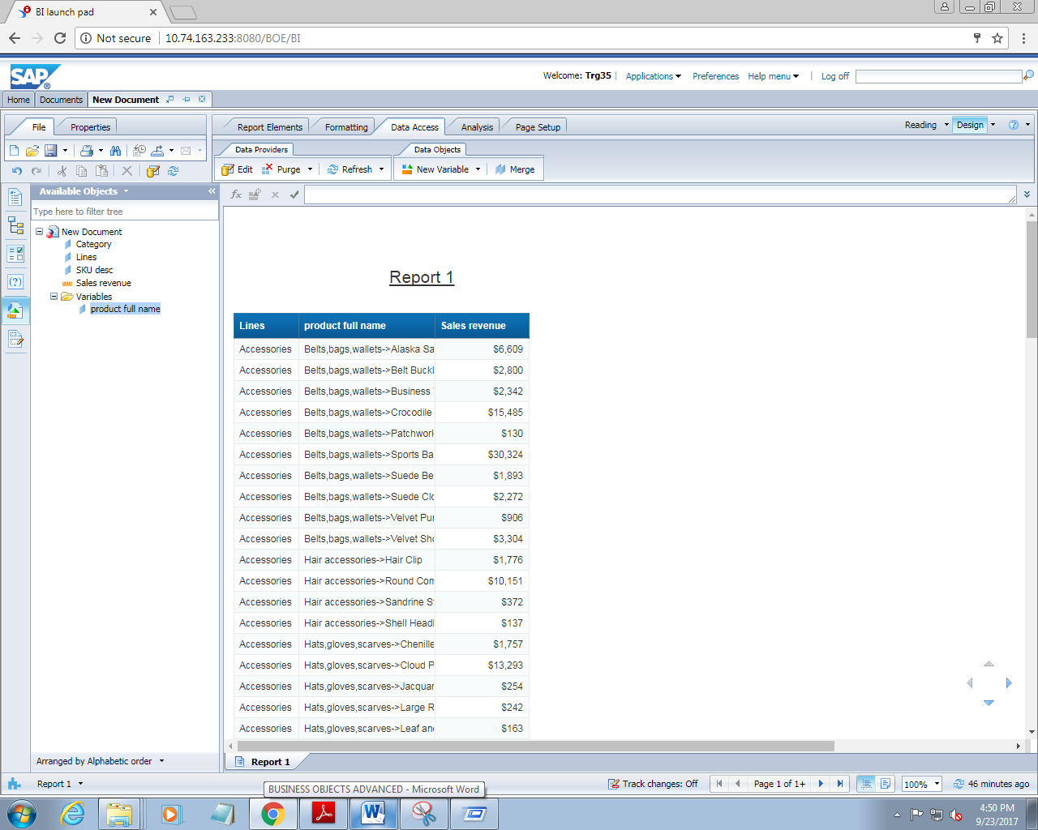

1. Save and run the query

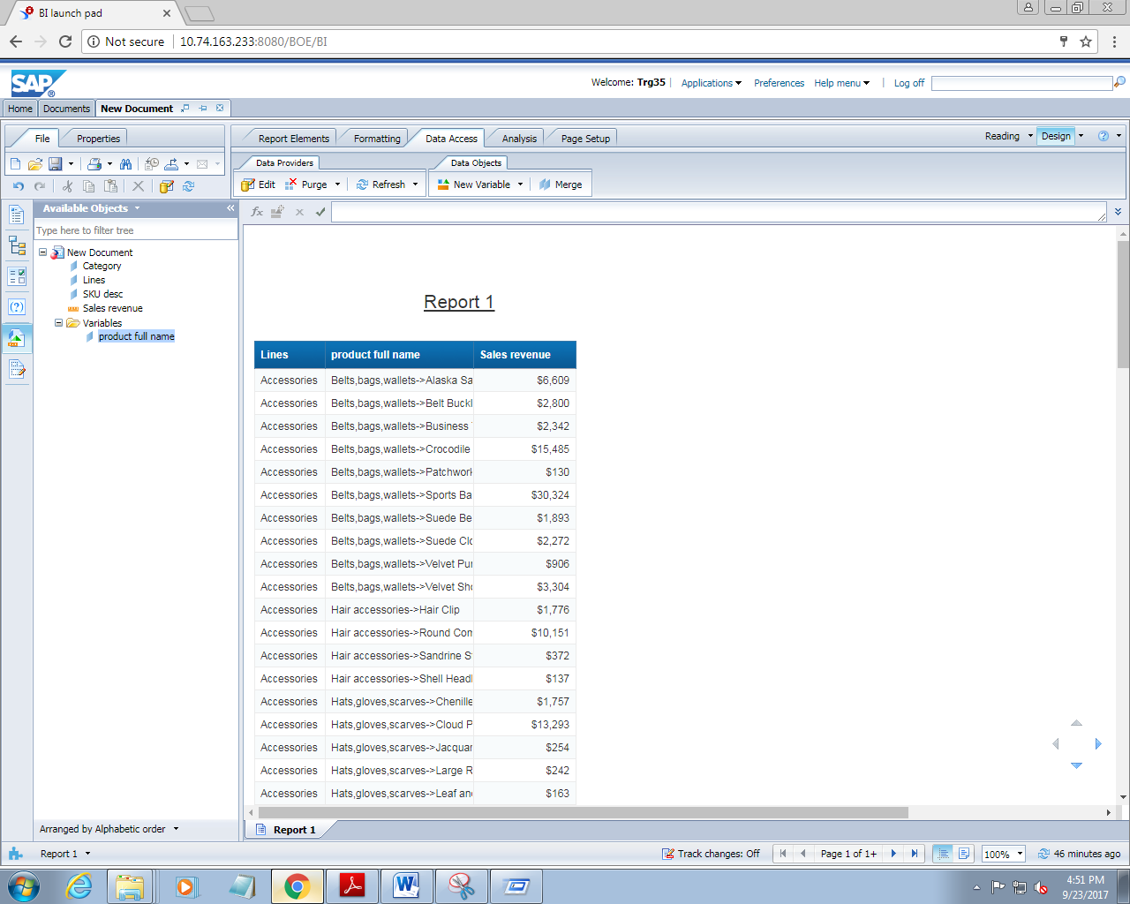

**4. PERFORMING LOGICAL GROUP OF VALUES**

1. Create a report which should contain the following dimensions

Lines, state and sales revenue

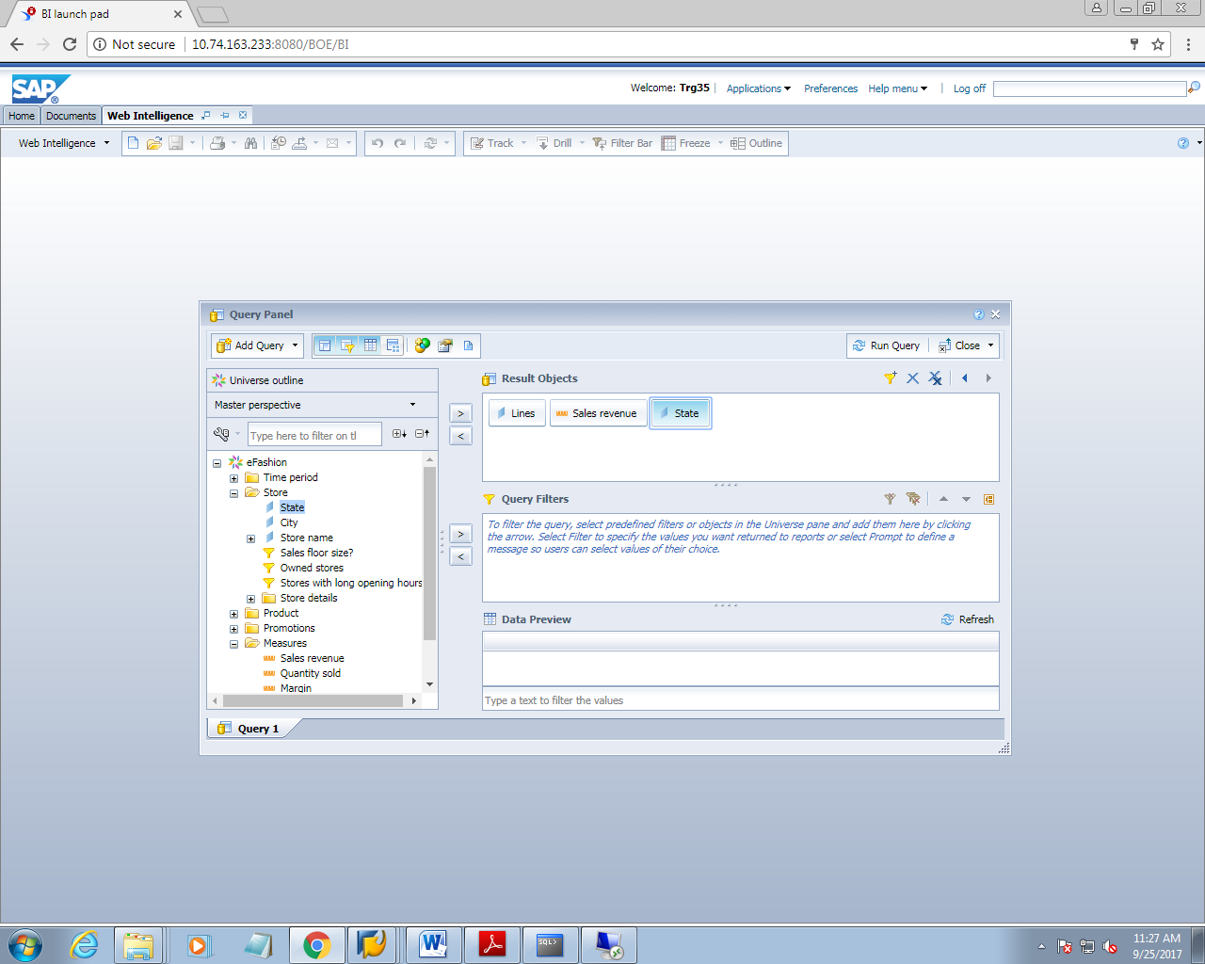

1. Add a prompt to dimension ‘year’

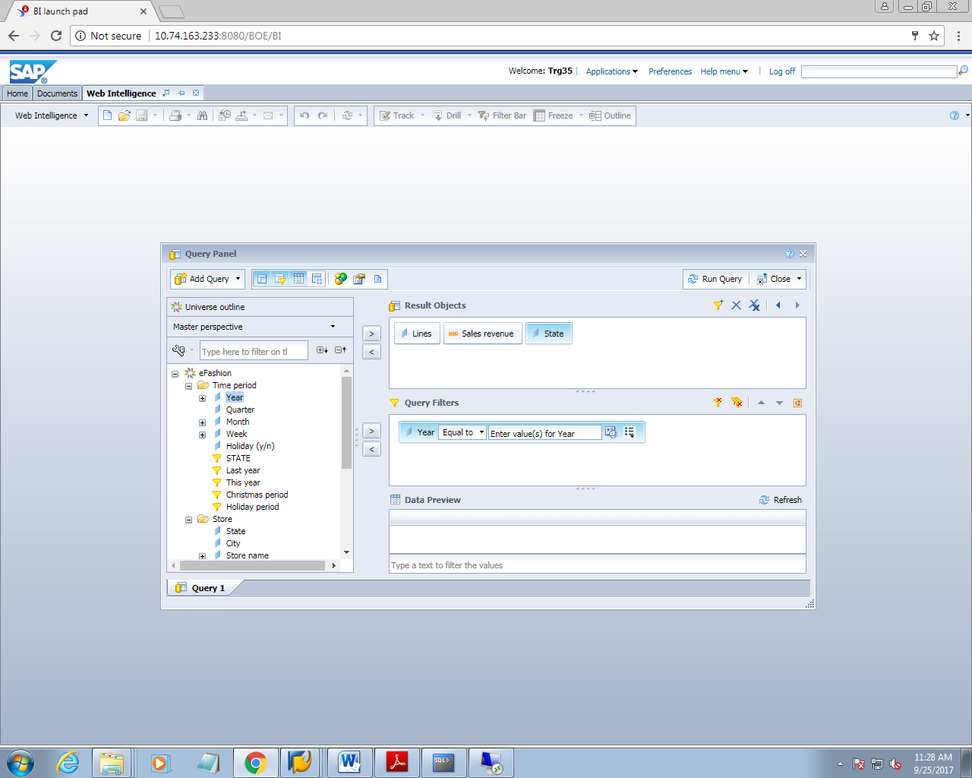

1. On clicking on run query, a prompt window will appear for entering the values

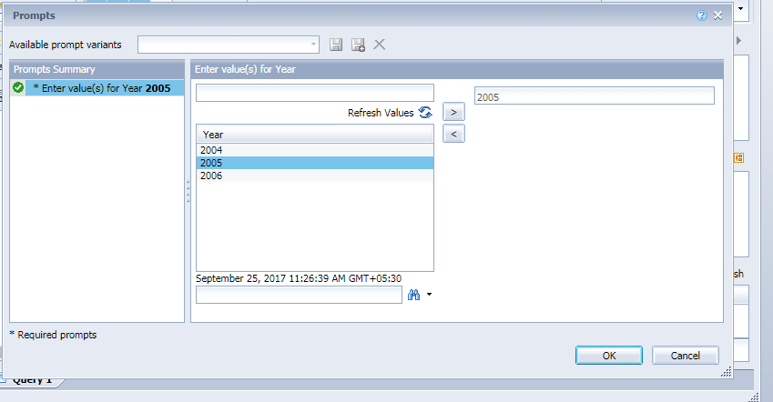

1. Click the run query button

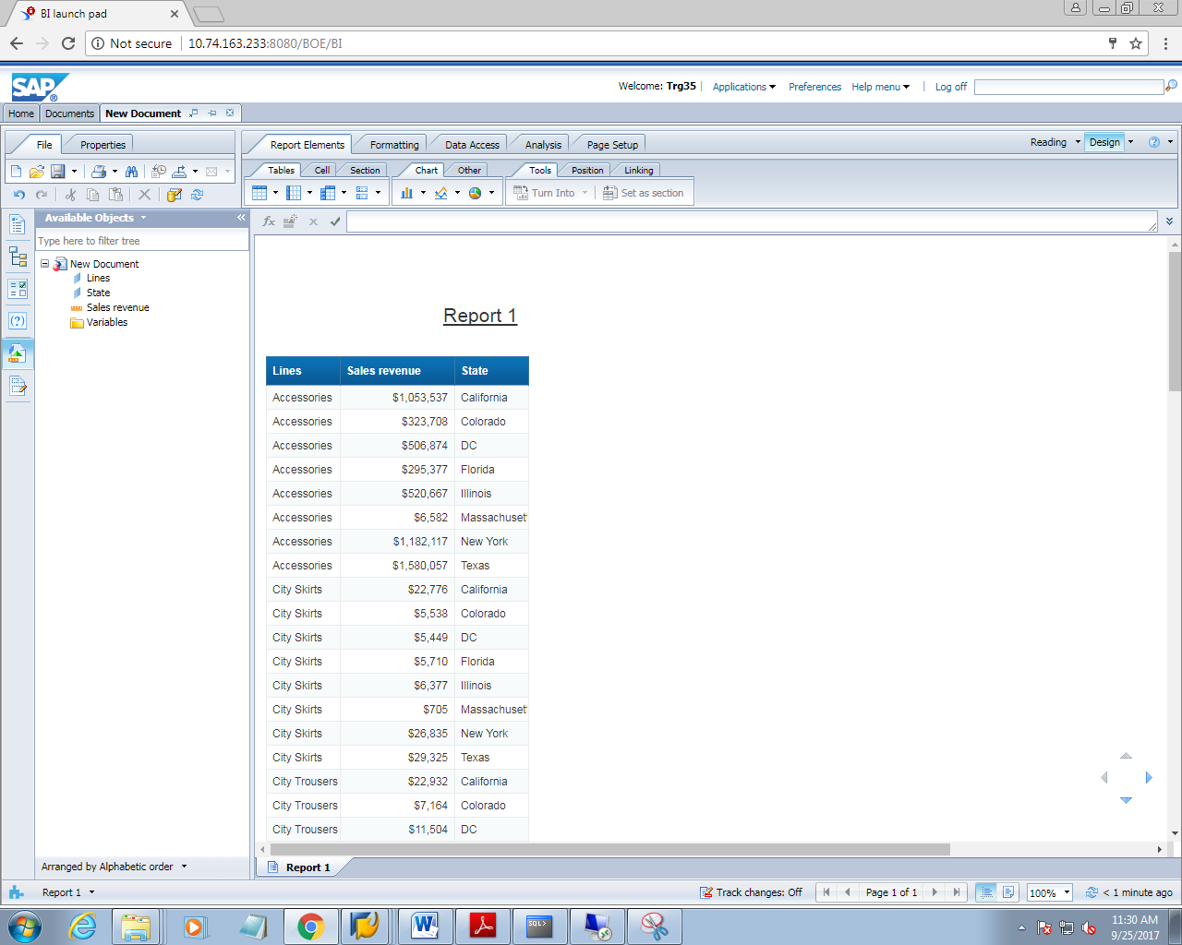

1. Now go to data access tab. Now click on new variable tab

On clicking on it, a window will appear a s below

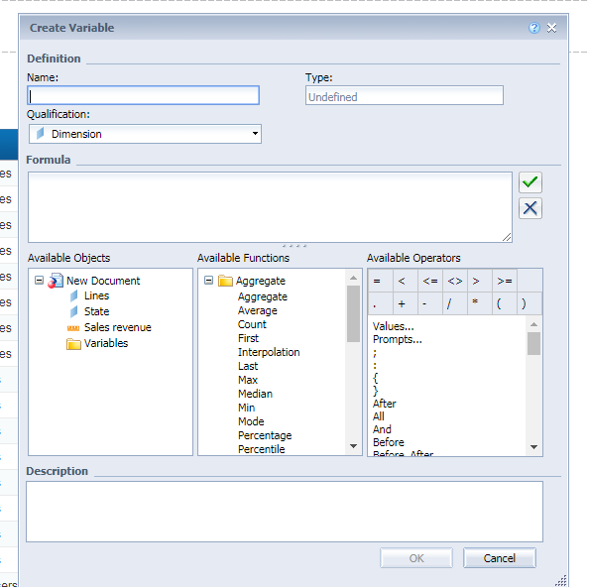

1. Fill the value and click on ok

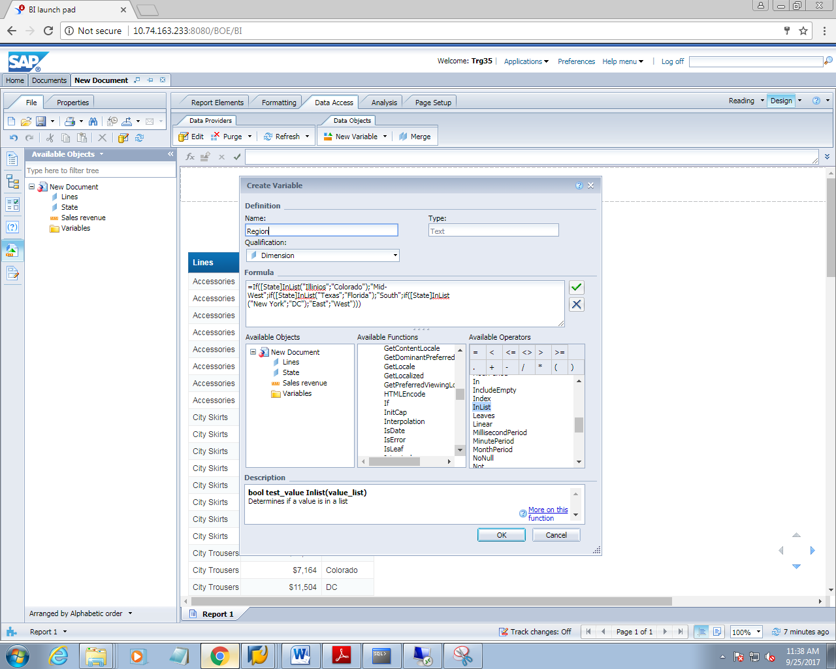

1. Replace the state column with region variable

Convert the table to cross table

See the report now

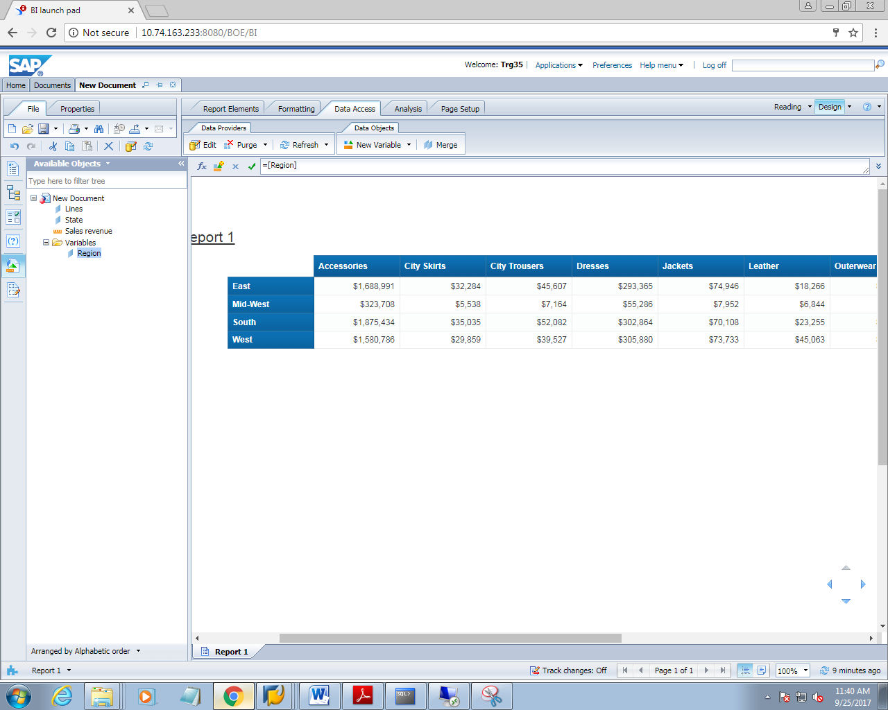

**5. APPLYING CUSTOM SORT**

1. Create a new report with the following dimensions

Month name and sales revenue

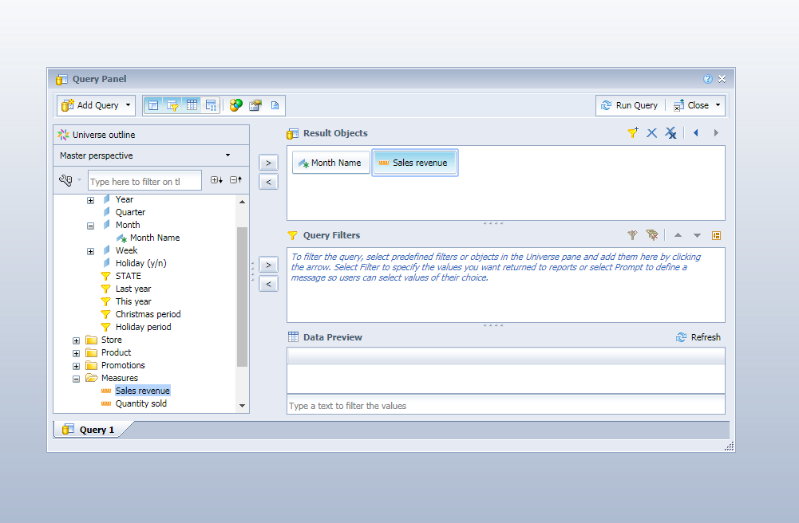

1. Add two prompts

Year and state. Give them prompt

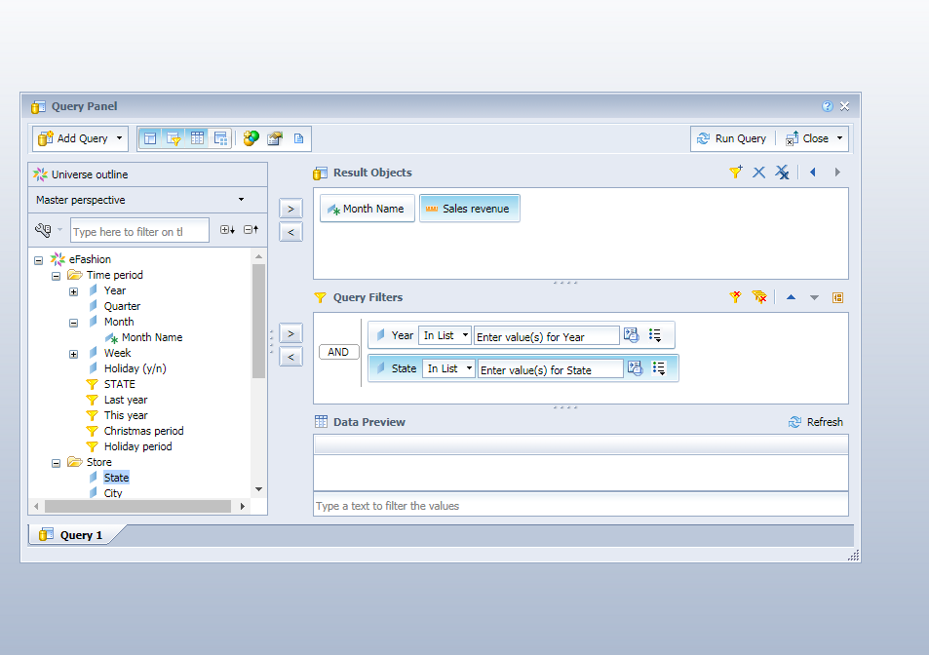

1. On clicking on run query, a prompt window will appear as

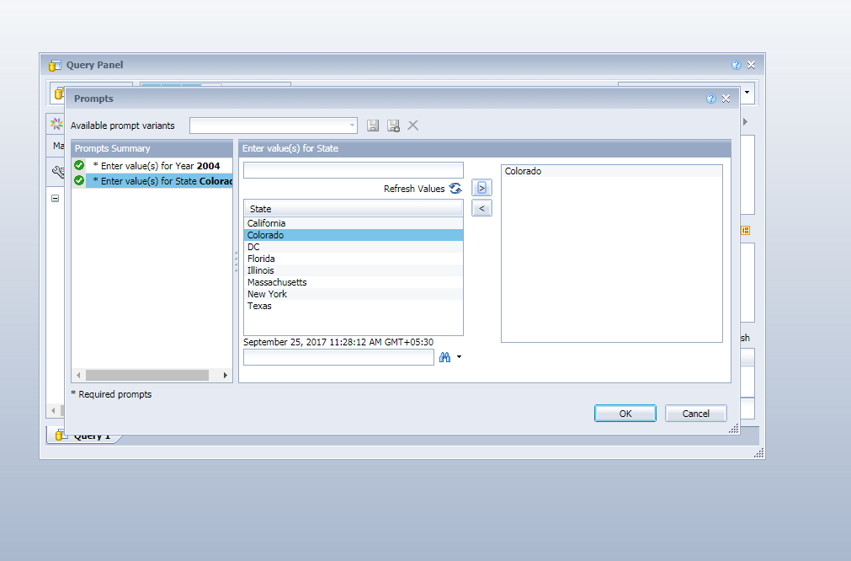

1. A report will generate as

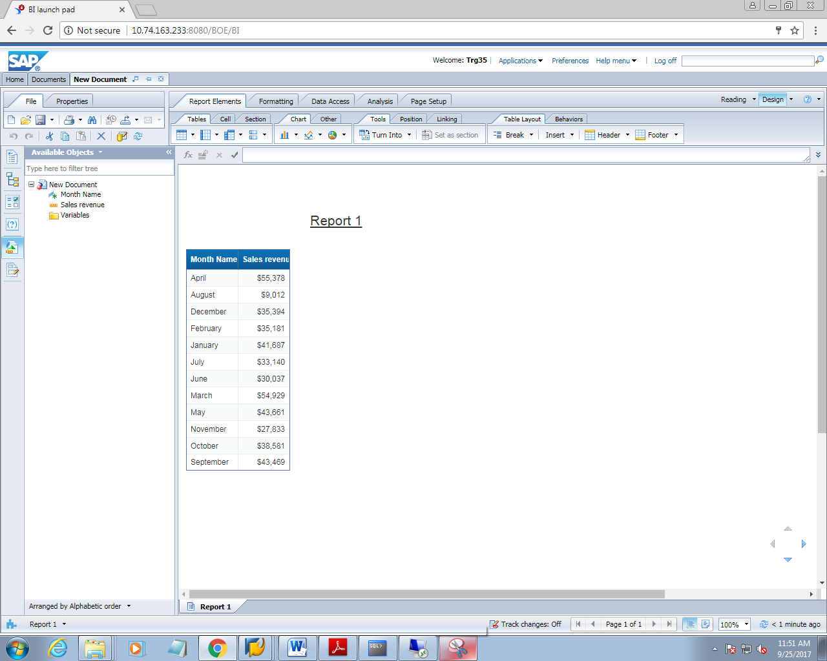

1. Right click on the moth name column and from pop up menu, point to sort and then to advanced

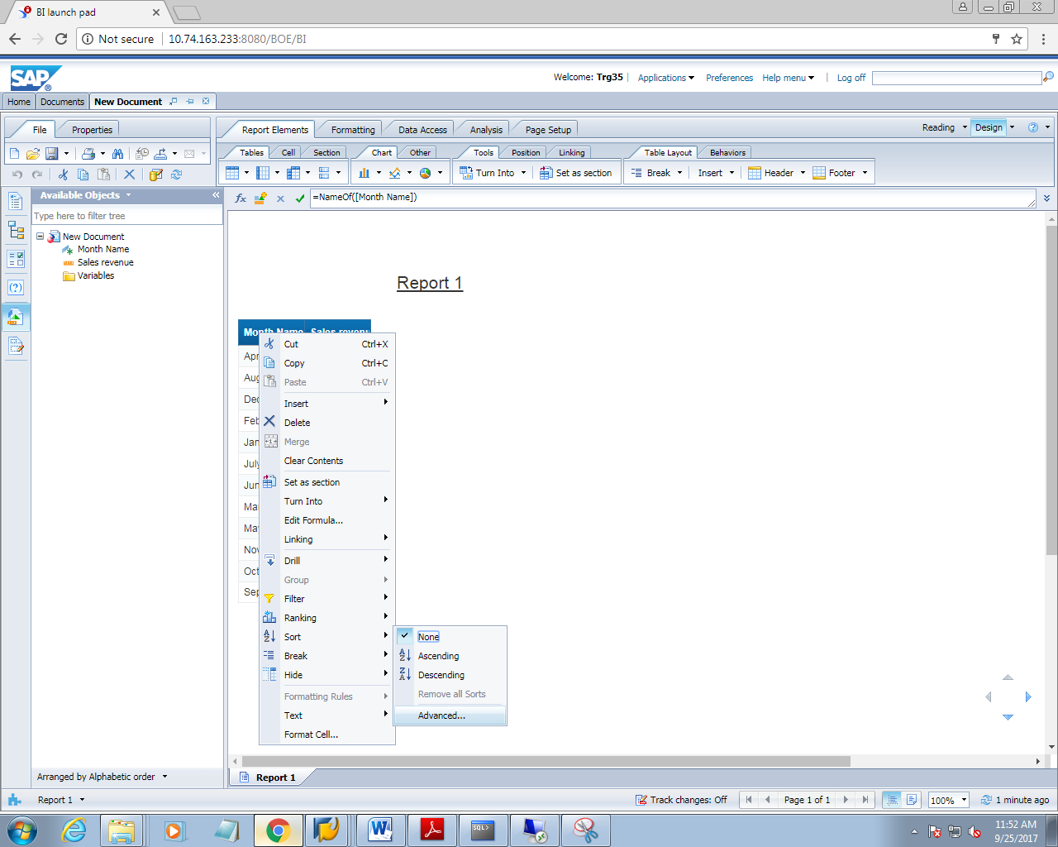

1. Now create a custom sort

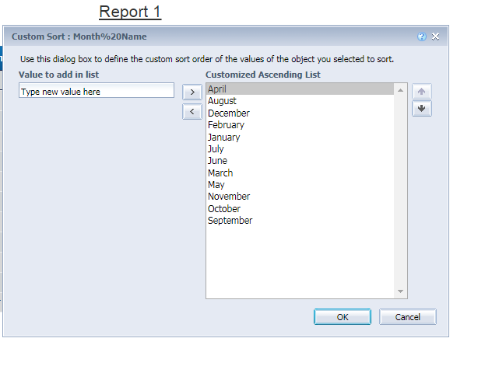7. Change the order of month using up and down arrays

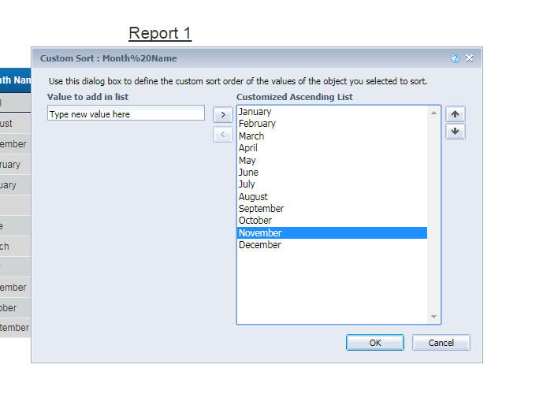

1. Click on ok and see the report

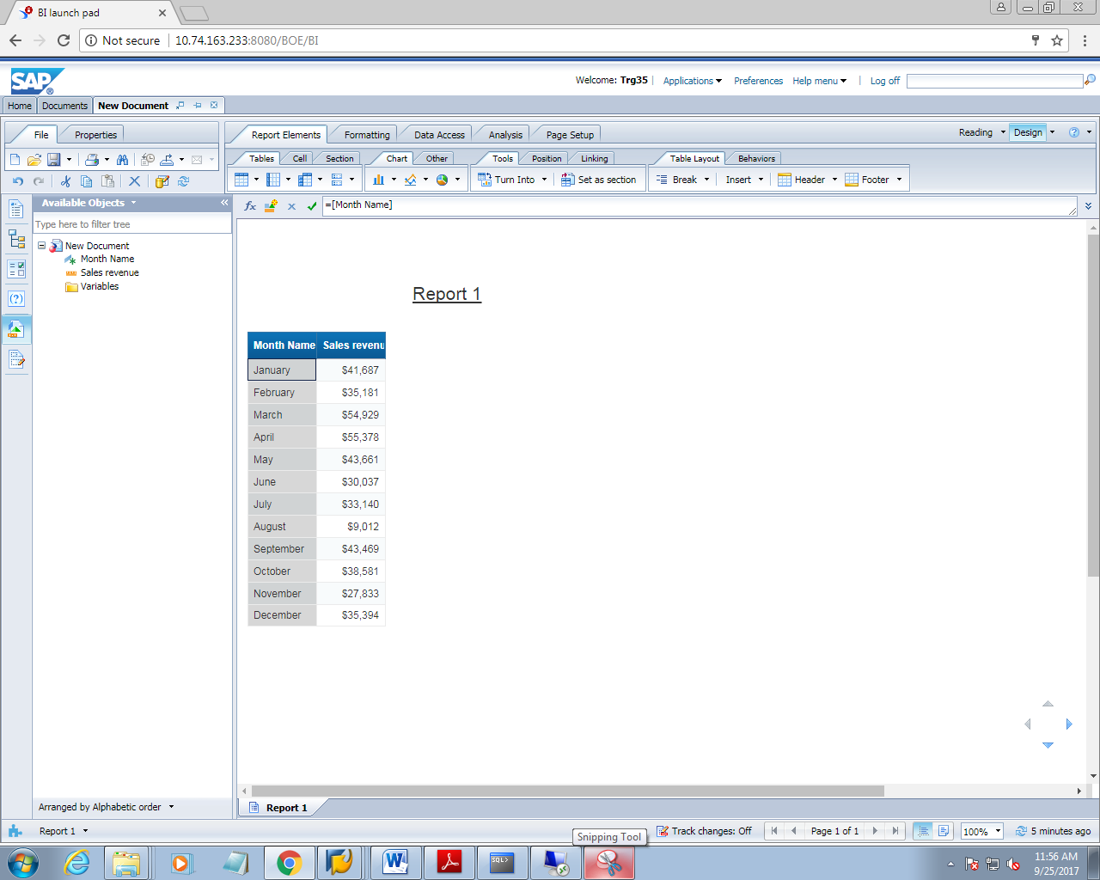

**6. USE RANKING TO VIEW TOP VALUES**

1. Create a new report which should use the following dimensions

Line, year and quantity sold

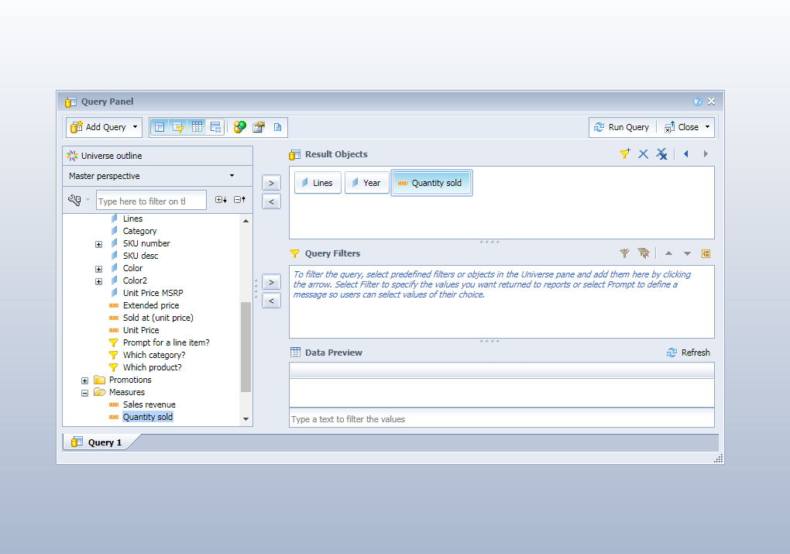

1. Now add two prompt

Year and sort

Set the value to prompt

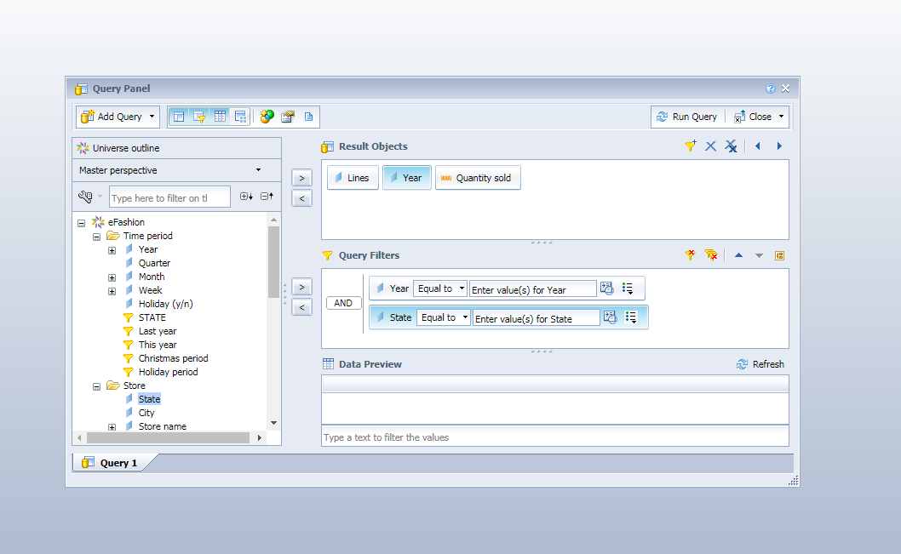

1. On clicking on ok . a prompt window will appear as

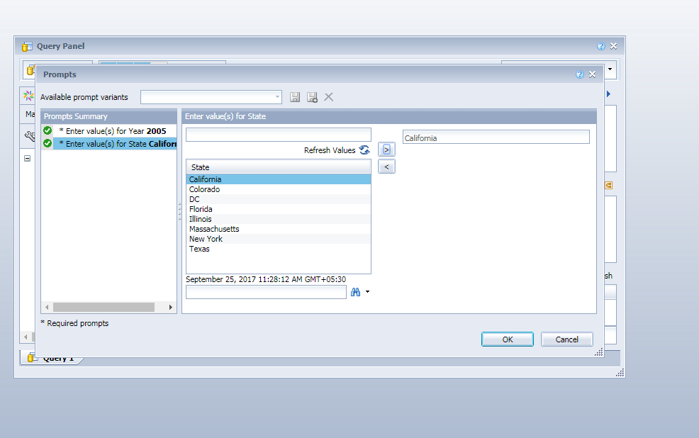

1. Now run the query

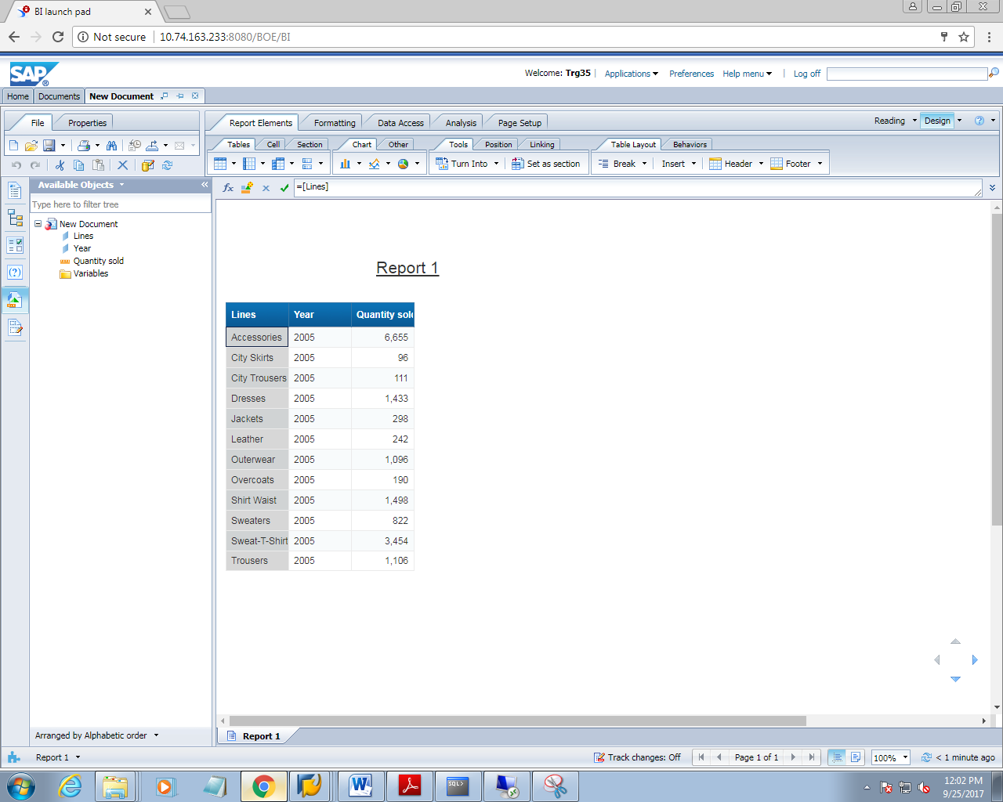

1. Now set the state as ‘section’

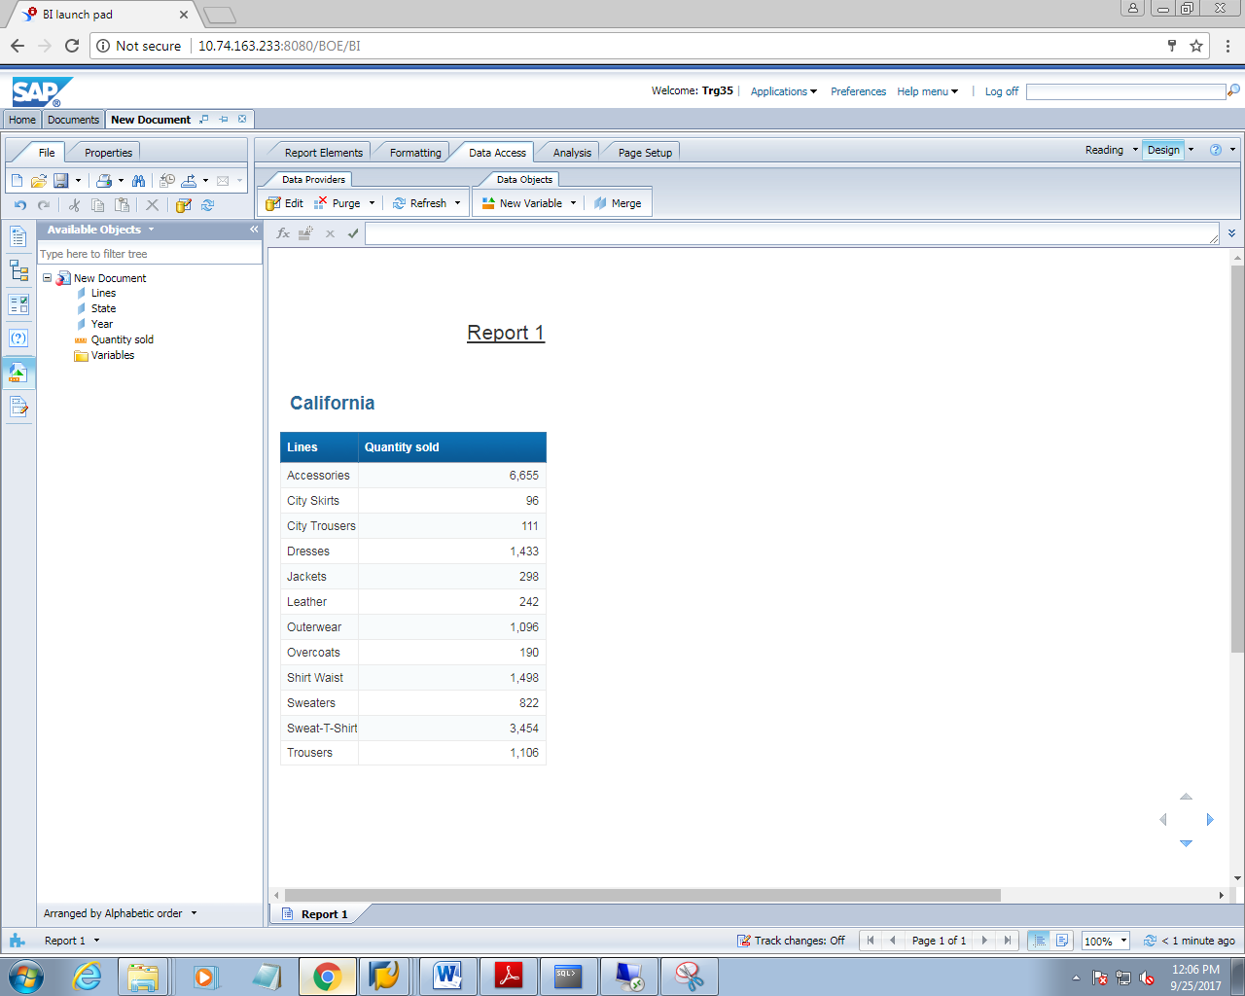

1. Select the line column and then click on apply ranking button

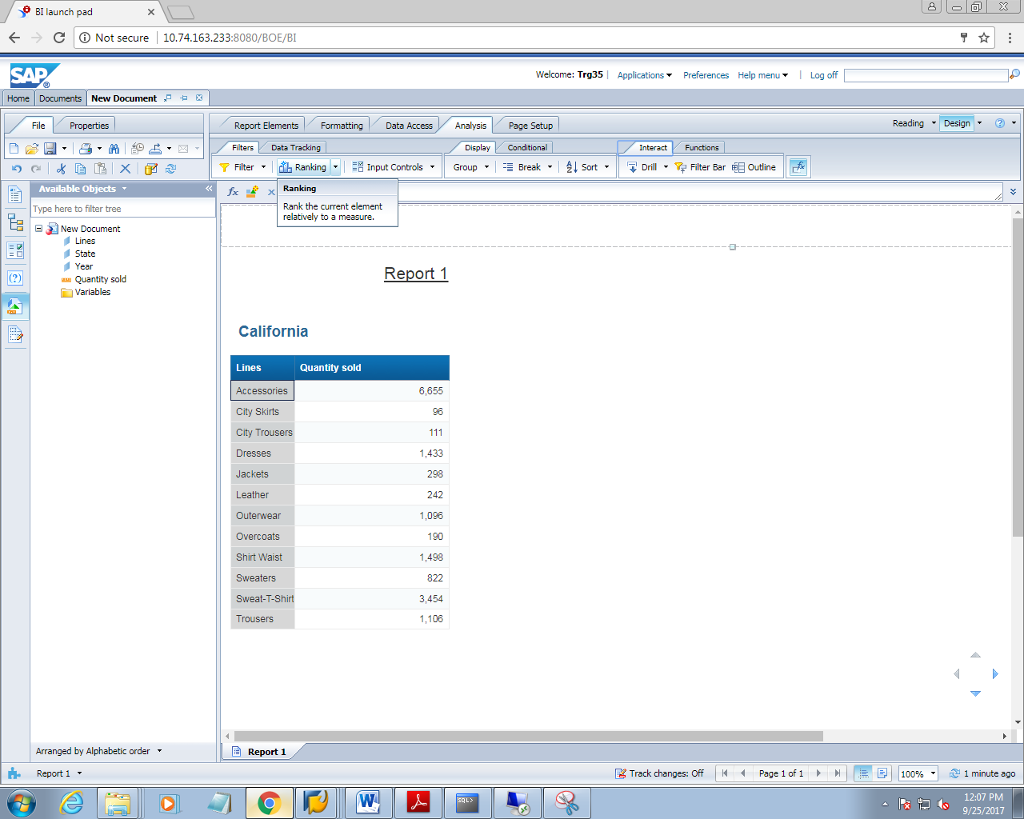

1. A window will appear on clicking on applying ranking button

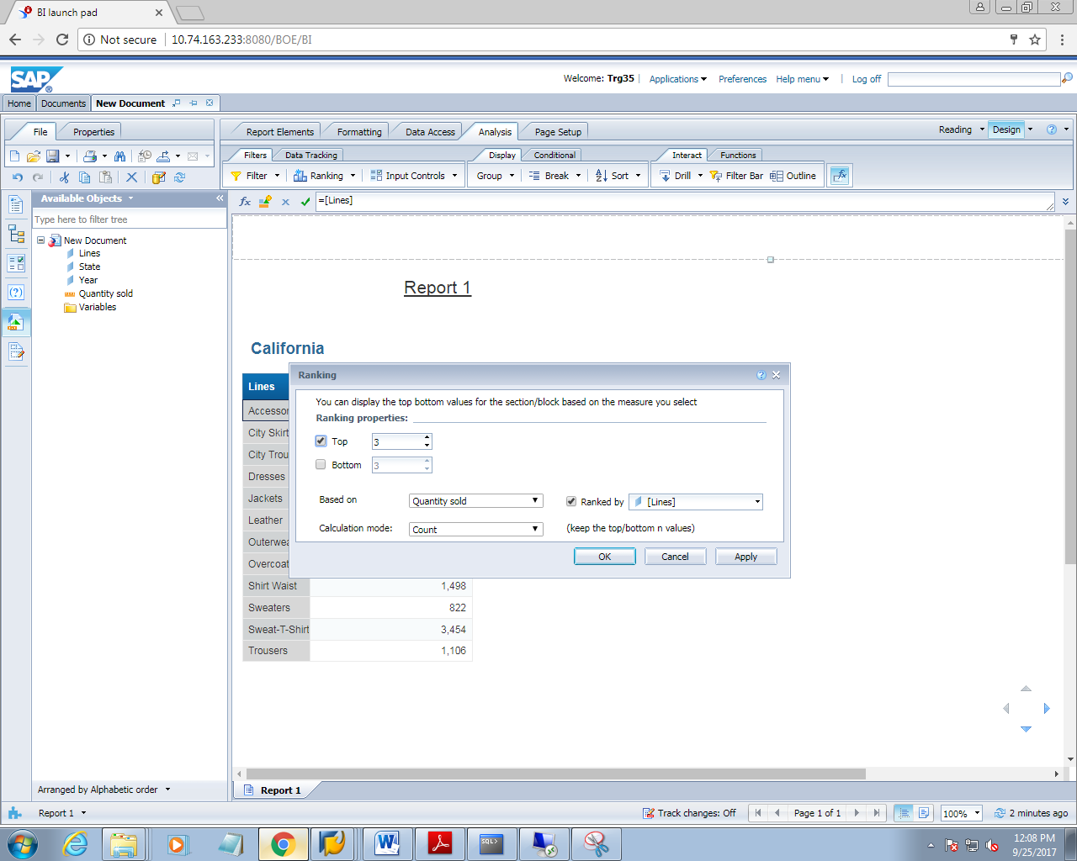

1. Click ok. The report will be as

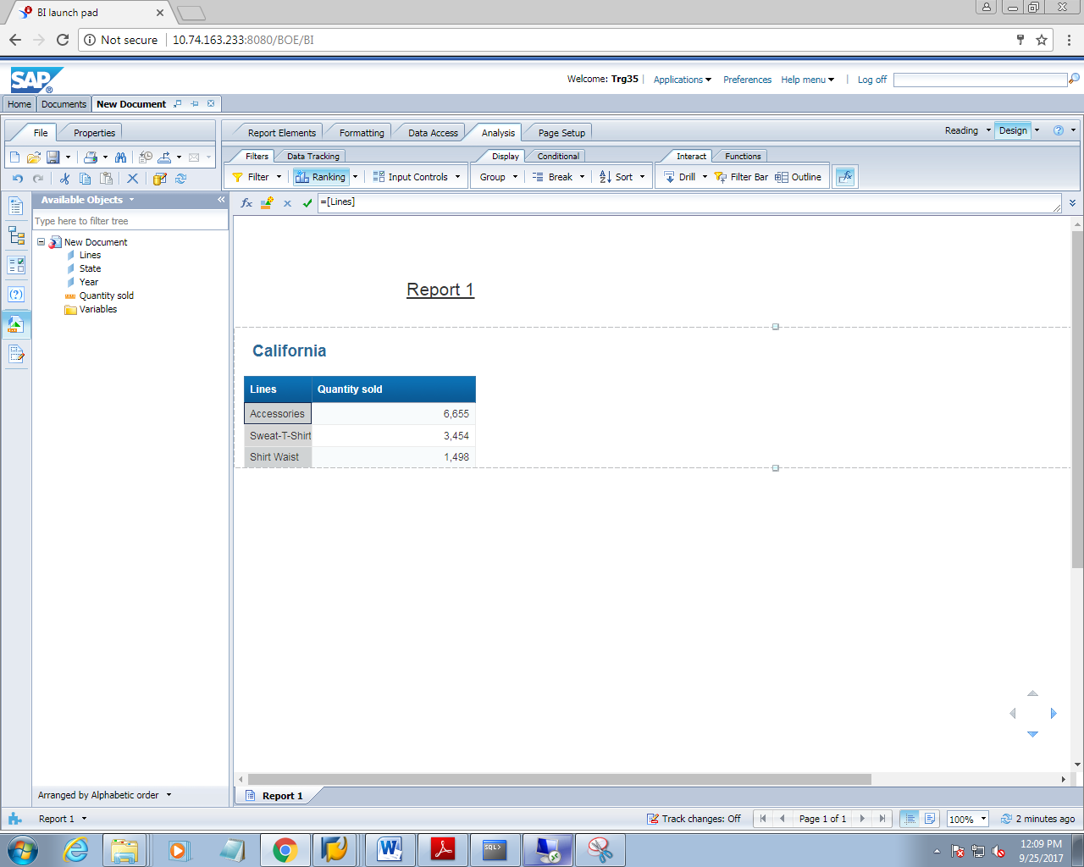

**7.1 CONTEXT SETTING**

1. Create a report which should contain the following dimensions

Year, quarter,state and sales revenue

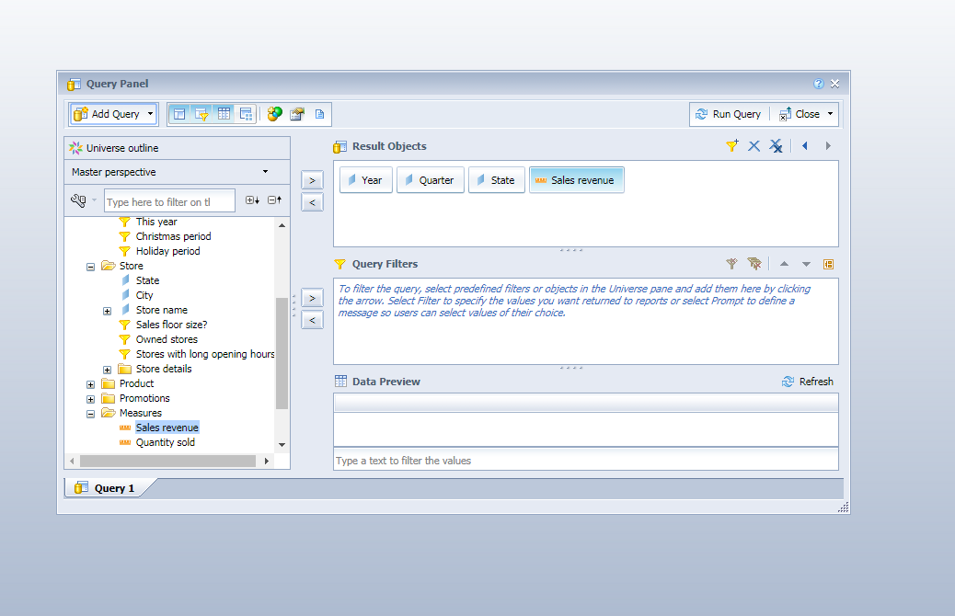

1. Click on run query

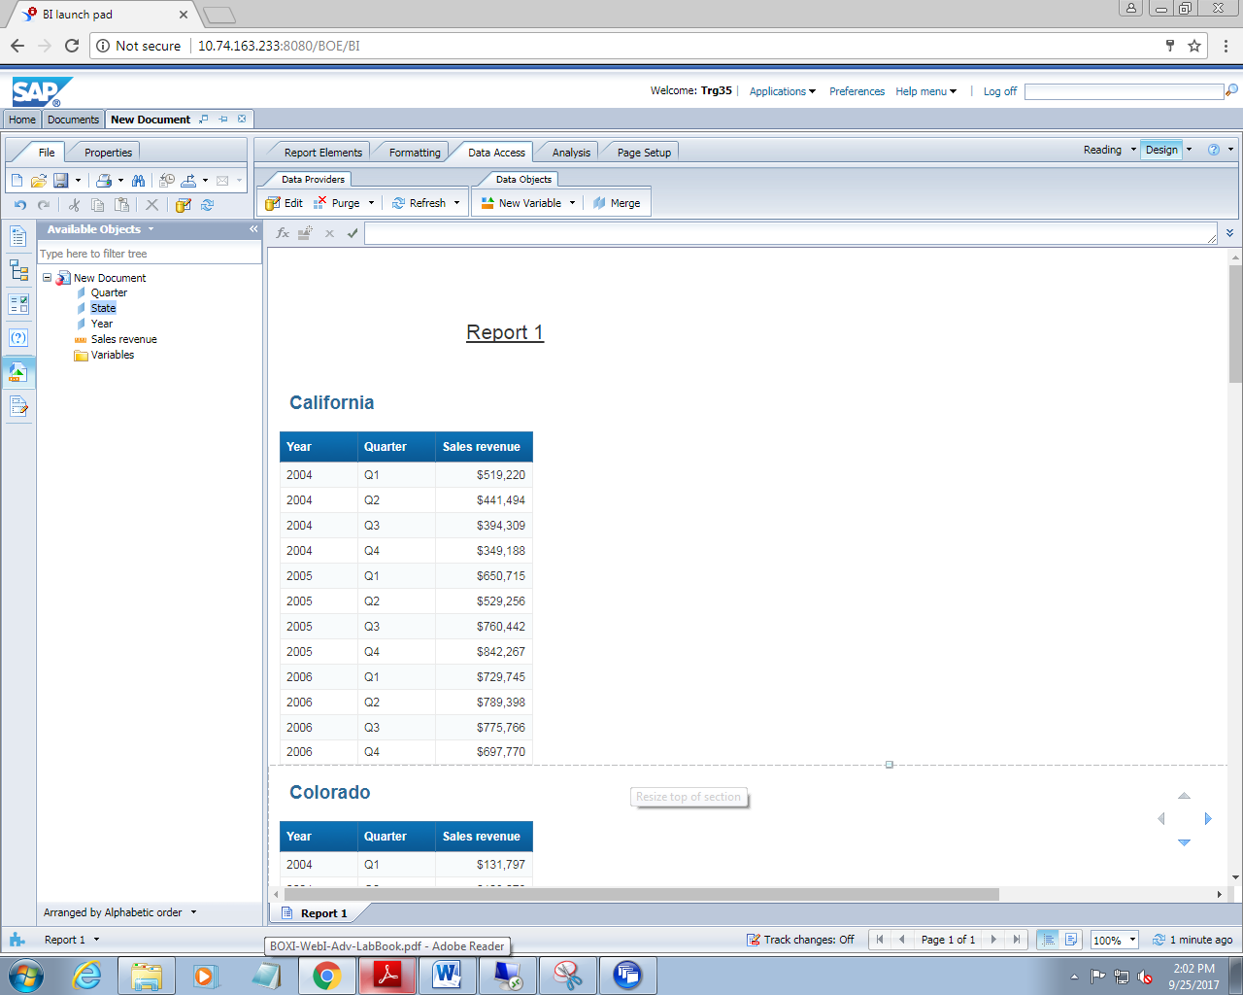

1. Go to data access tab. Under this go to new variable tab.

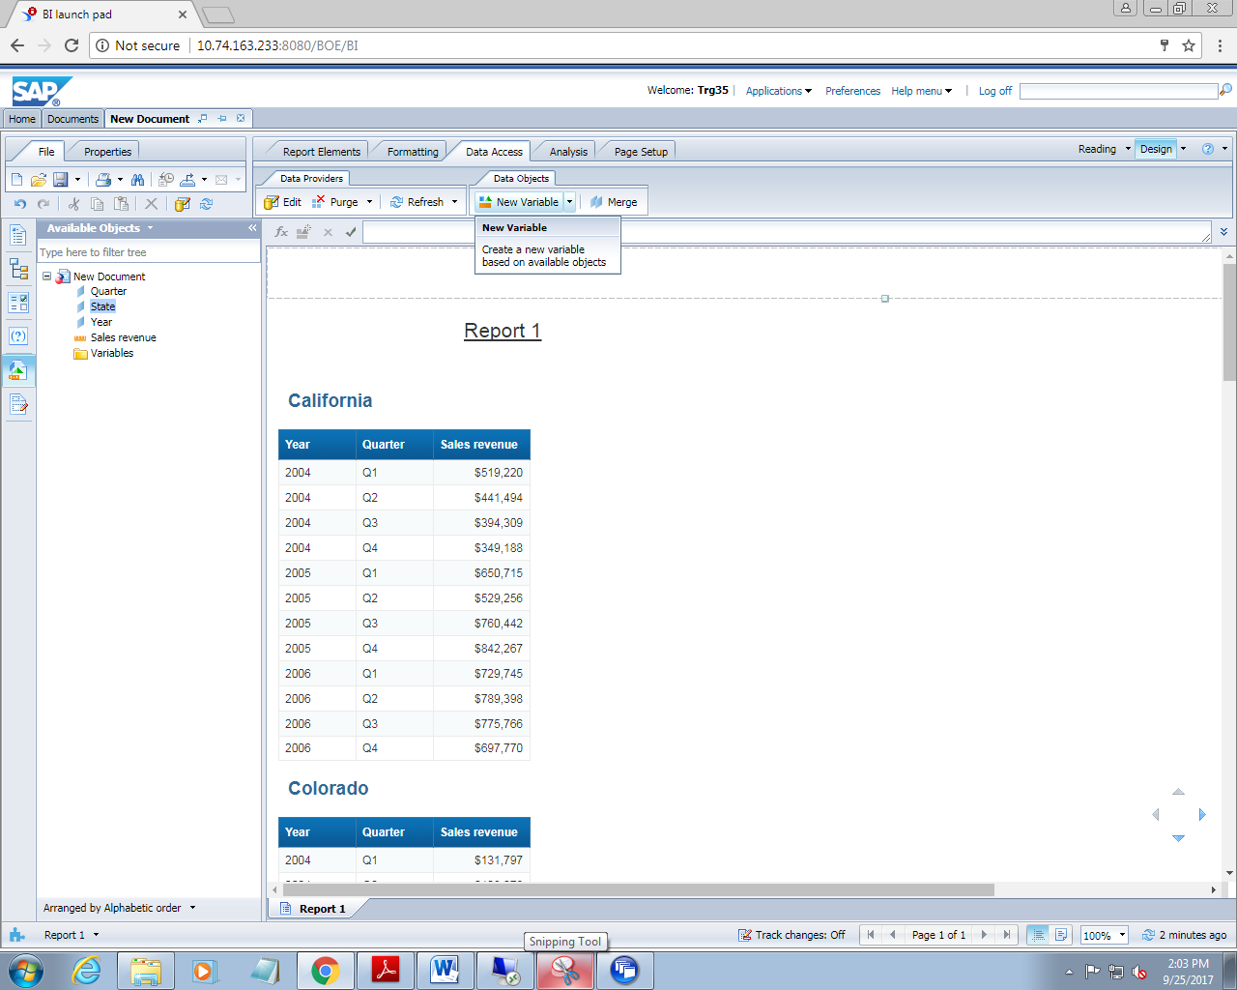

1. On clicking on new variable, a window appears as

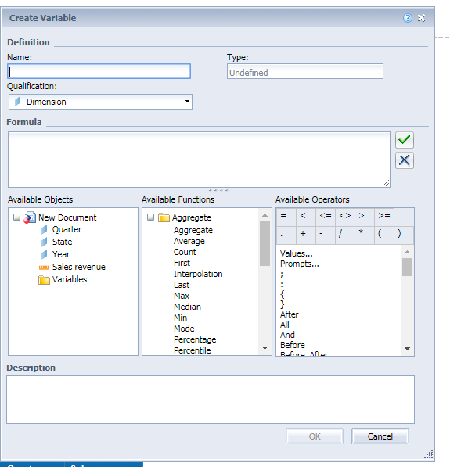

1. Write the formula as

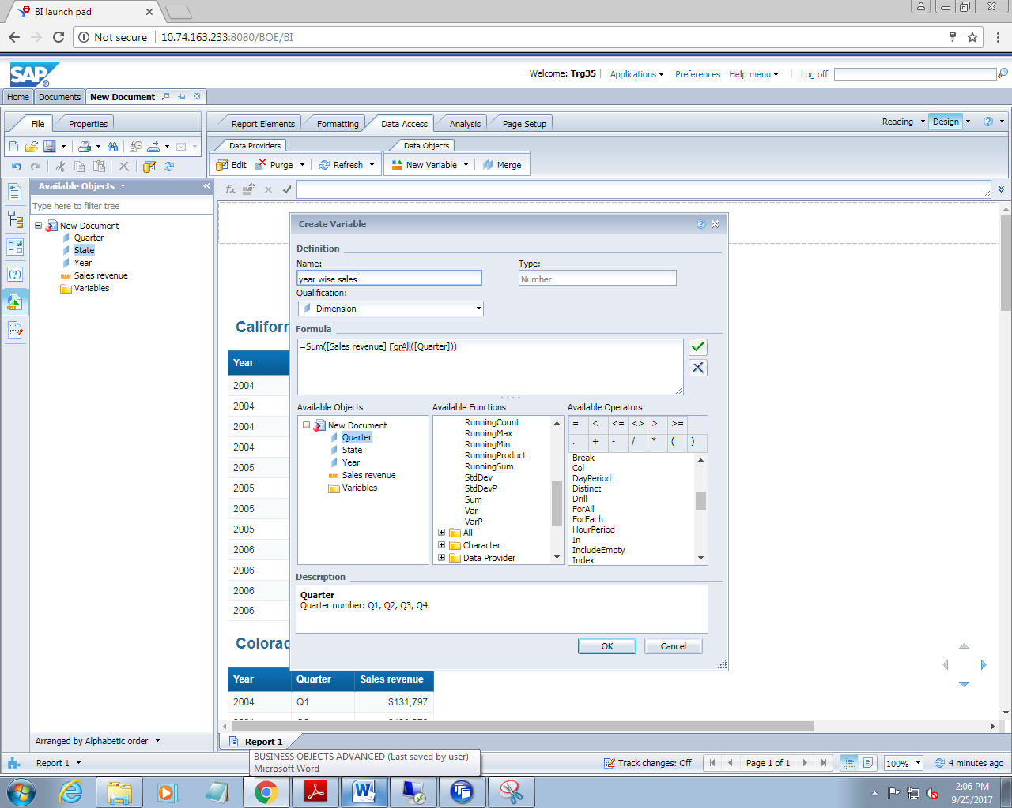

1. Insert the newly created variable to the right of sales revenue column to the report

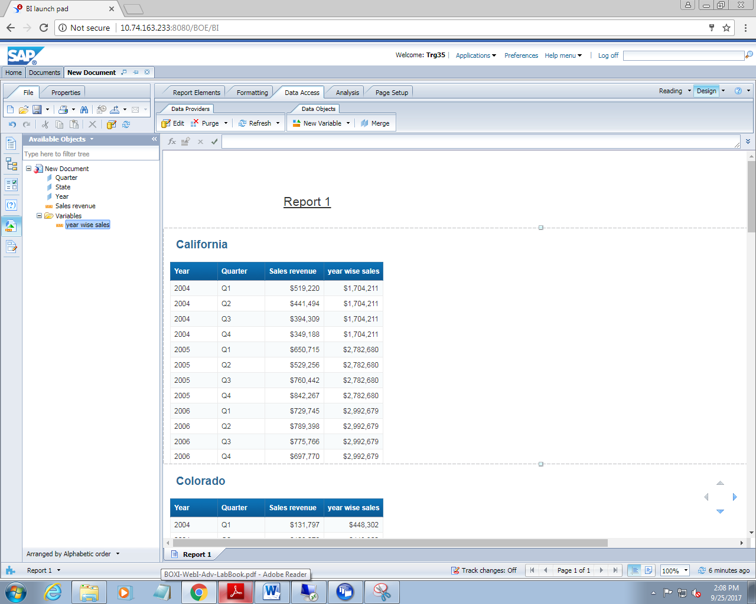

1. Now insert another column after ‘years sales’ variable. Add the formula to calculates sales percentage for quarter

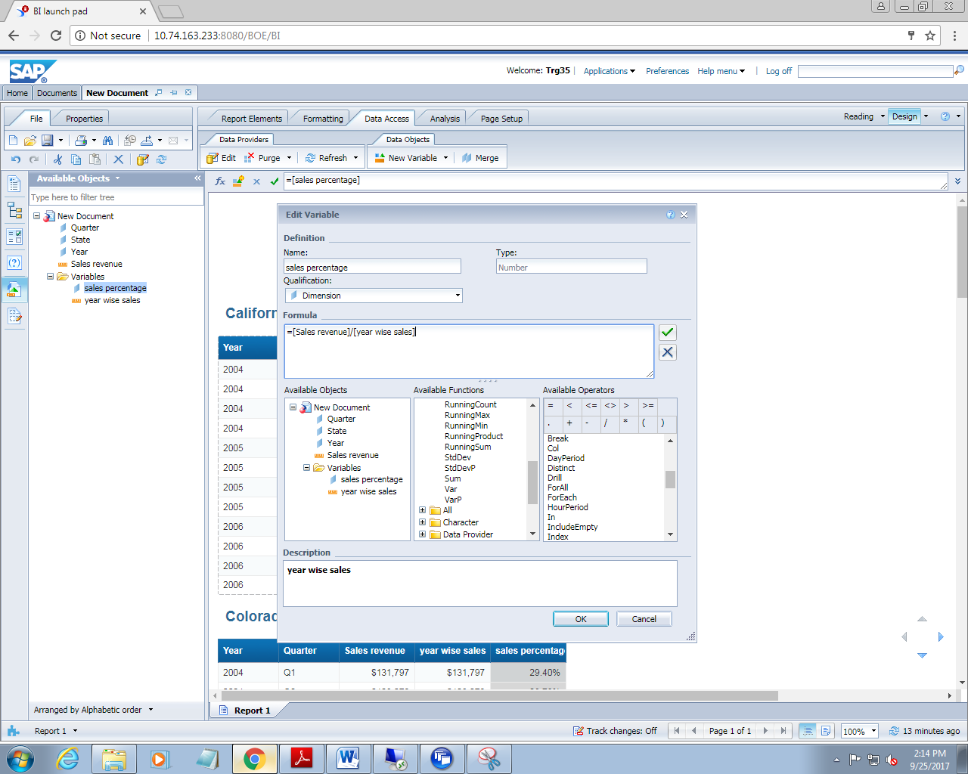

1. Now see the result

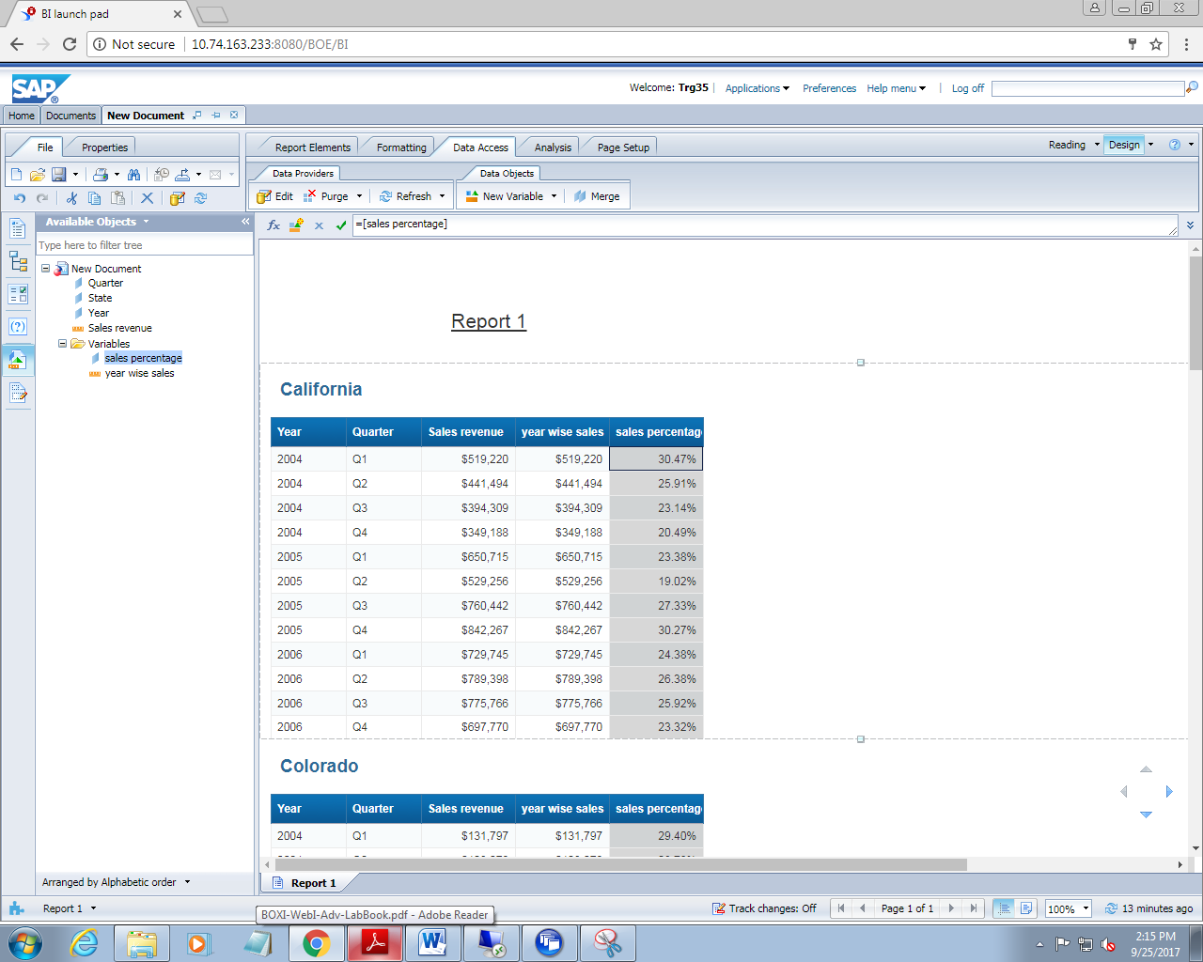

**7.2 USE THE RANK FUNCTION AND SET THE CONTEXT**

1. Create a new report which should include following dimensions

Year, quarter,line and sales revenue

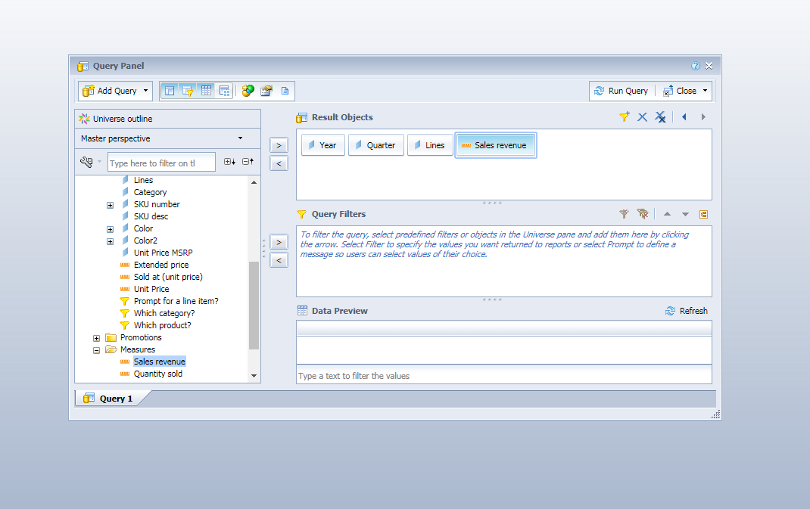

1. Click on run query

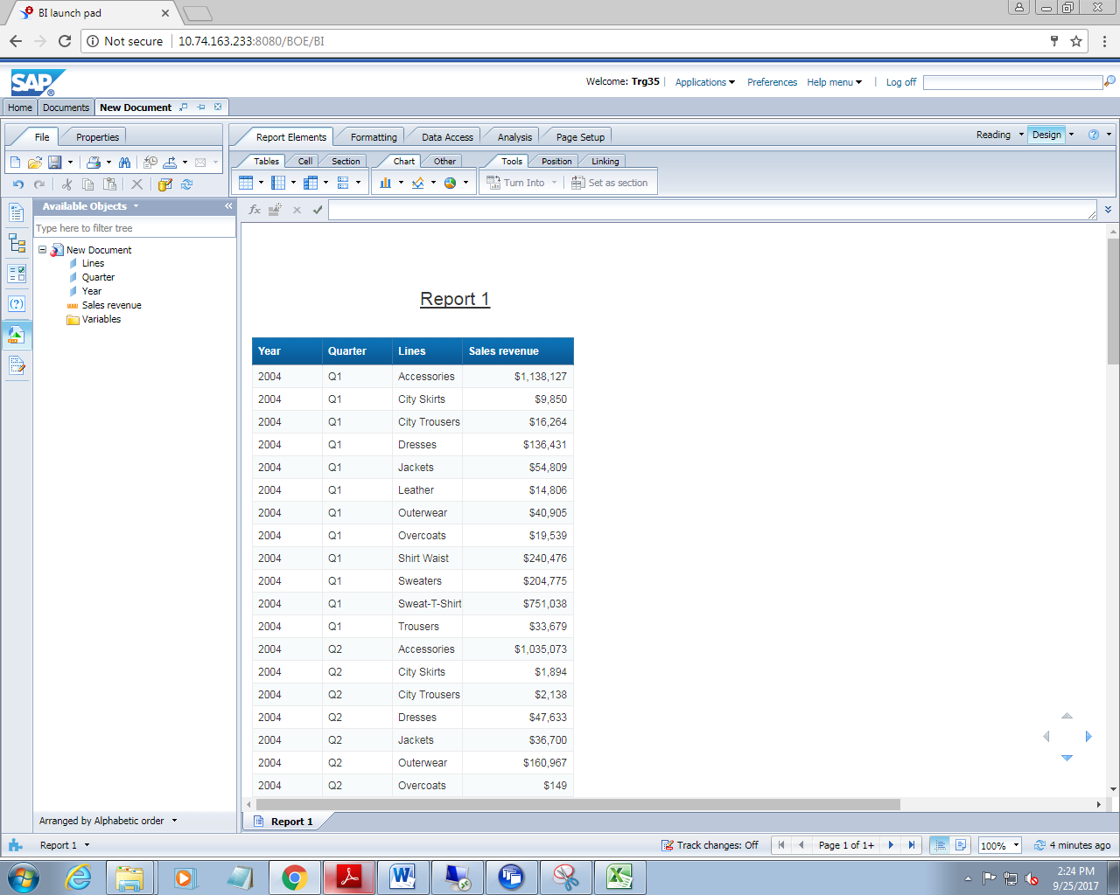

1. Now change it to crosstab and set state as section

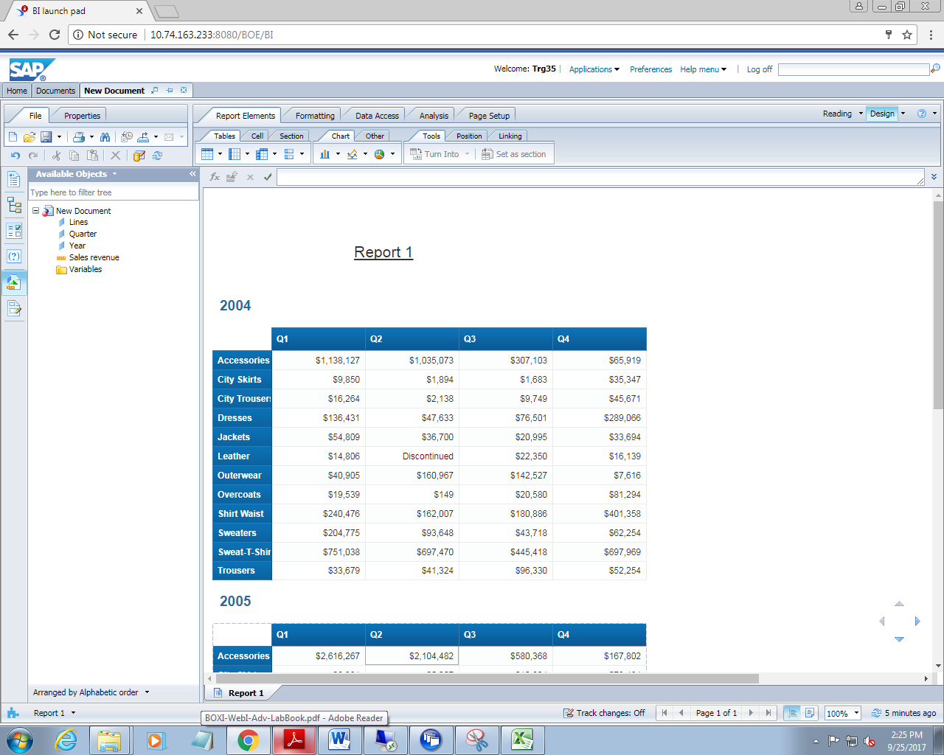

1. Insert a column named rank to the right and insert the formula as

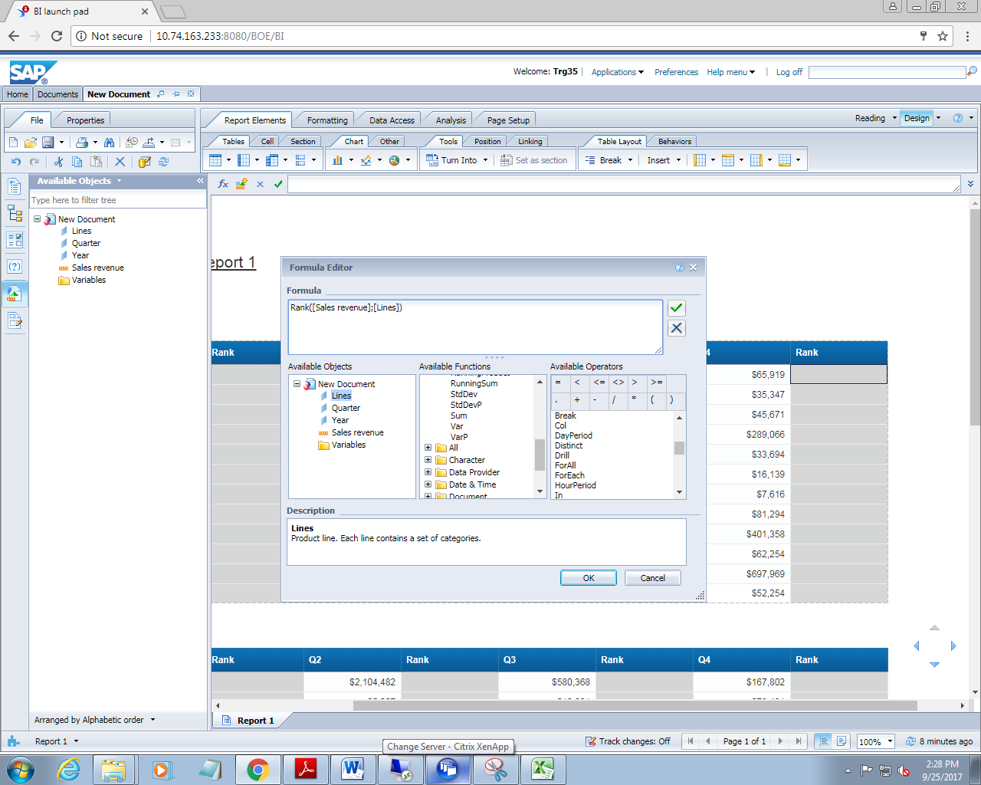

1. Click on ok and see the result

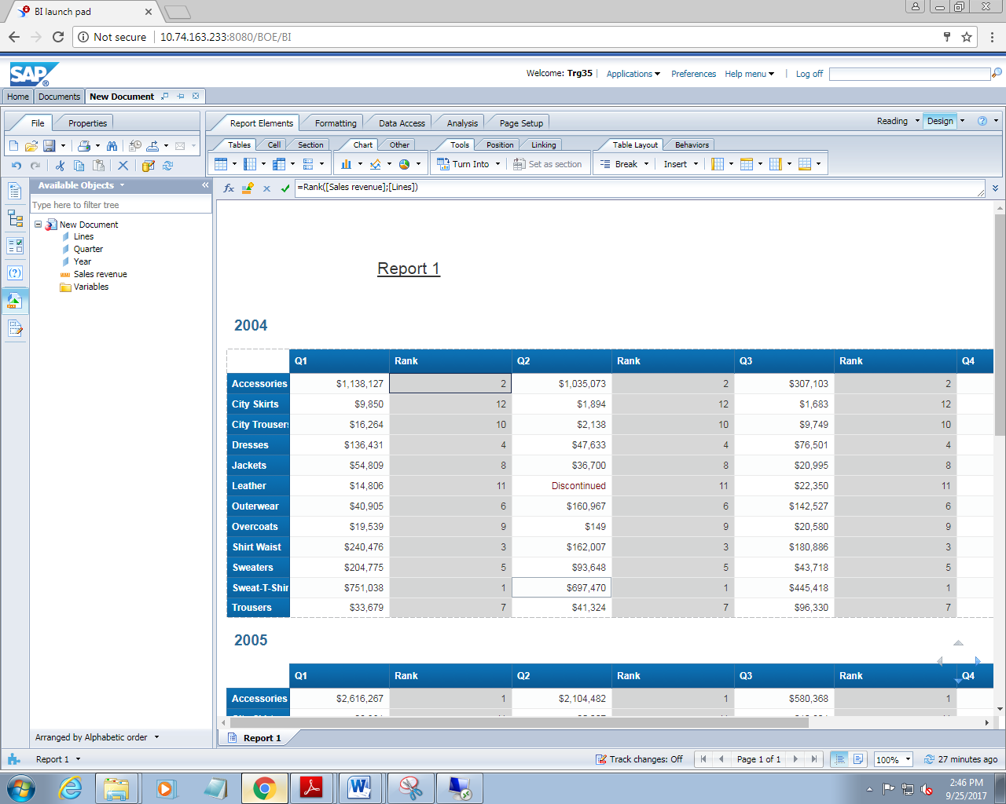

The output is not correct. Change the formula as

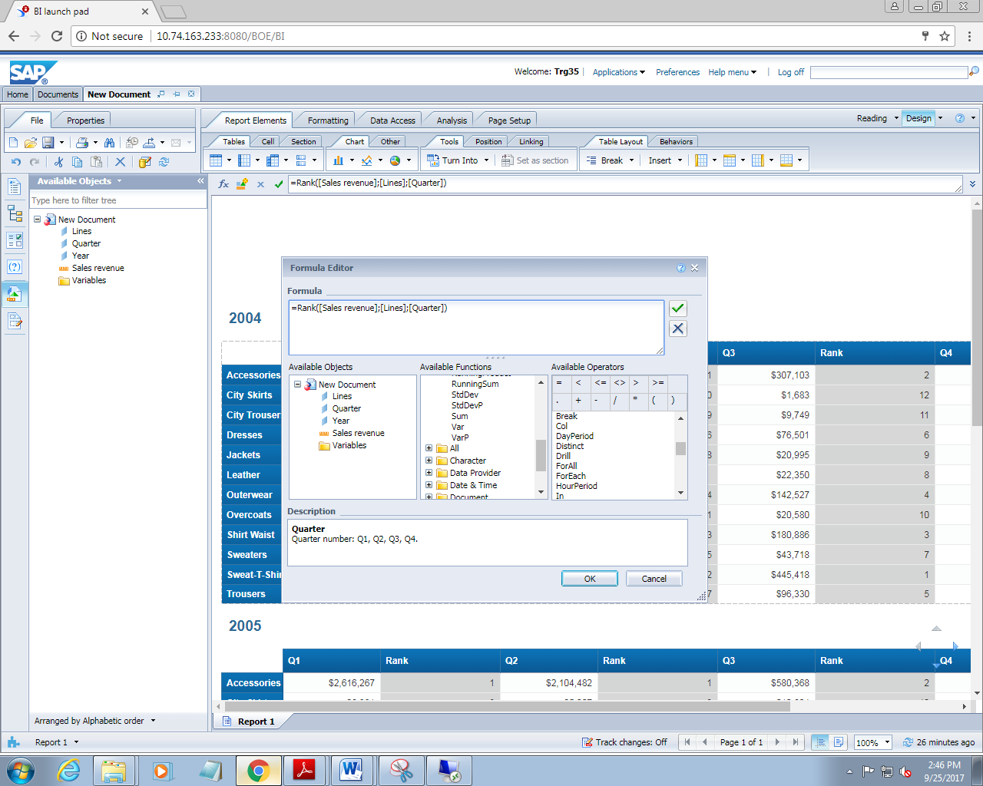

Click on ok and see the result now

